NATIONAL ASSEMBLY
36/1/4/1(201900073)

FOR WRITTEN REPLY

QUESTION 616

DATE OF PUBLICATION IN INTERNAL QUESTION PAPER: B MARCH 2019 (INTERNAL QUESTION PAPER NO 7-2019)

616. Mr W M Madisha (Cope) to ask the Minister of Police:

What (a) is the average processing time for the consideration and approval of firearm competency certificates, (b) is the current backlog for the processing of such applications and (c) are the reasons for this backlog?
NW739E
REPLY:

- The average processing time for the consideration and approval of firearm competency certificates is 90 working days.

- On 11 March 2019, a total of 6 190 competency applications had exceeded the target of 90 working days.

- The reasons for the backlog, range from outstanding illicit reports from the Criminal Record Centre and system challenges, such as the slowness of the system.

Reply to question 616 recommended/

GENERAL AFRICAN POLICE SERVICE
CO E (SO
ER

Date: !!" ” ' '

Reply to question 616 approved
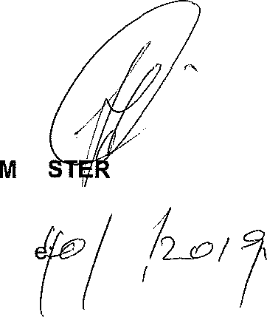
INI
OF POLICE
BH CEEE, MP
Dat
6/,

