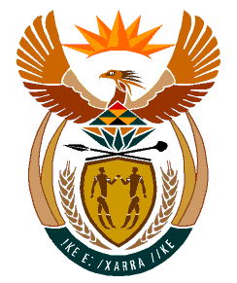

MINISTRY
HUMAN SETTLEMENTS
REPUBLIC OF SOUTH AFRICA

Private Bag X645, Pretoria, 0001. Tel: (012) 421 1309, Fax: (012) 341 8513

Private Bag X9029, Cape Town, 8000. Tel (021) 466 7603, Fax: (021) 466 3610

NATIONAL ASSEMBLY
QUESTION FOR ORAL REPLY
QUESTION NUMBER: PQ 610 ((NW743E)
DATE OF PUBLICATION: 1 APRIL 2022

610 Mrs. S M Mokgotho (EFF) to ask the Minister of Human Settlements:

By what date will the Reconstruction and Development Programme houses in ward 6 in Mamusa Local Municipality that were started in 2015, but left incomplete be completed?
REPLY

According to the response received from the Provincial Department of Human Settlements, It is anticipated that the houses will be concluded by 31 December 2022. However, it must be mentioned that since the inception of the project, two contractors have been appointed, one in 2015 and the second one in 2017, both abandoned the project. The project currently has the following milestones:
- 121 Foundations,
- 79 Wall plates and
- 10 Completed units

The Department has since allocated its internal Inspectors, NHBRC, and the Planning Unit through the assistance and appointment of a Quantity Surveyor to further ascertain the milestones on the ground and determine the costs before the appointment of another contractor.

