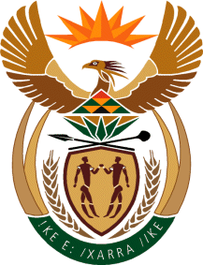

MINISTRY:COMMUNICATIONS
REPUBLIC OF SOUTH AFRICA
Private Bag X 745, Pretoria, 0001, Tel: +27 12 473 0164 Fax: +27 12 473 0585
URL: http://www.gov.za
NATIONAL ASSEMBLY
QUESTION FOR WRITTEN REPLY
QUESTION NUMBER: 607 OF 2016
DATE OF PUBLICATION: 26 FEBRUARY 2016
Ms D Carter (COPE) to ask the Minister of Communications:
Whether she had (a) ascertained if the SABC bosses had issued any directives prohibiting talk show hosts from keeping open lines on current affairs until the end of the local government elections and (b) made it clear that Sections 15 and 16 of the Constitution had to be honoured irrespective of the political affiliation of the SABC bosses, if not, why is she failing in her duty to provide constitutionally directed leadership; if so, what are the relevant details? NW719E

REPLY: MINISTER OF COMMUNICATIONS

- The South African Broadcasting Corporation (SABC) management did not prohibit talk show hosts from having open lines discussions during programmes. Presenters / talk show hosts of for example religious or sport programmes are subject matter experts and will have open line discussions on relevant religious or sporting matters. At the same time political discussions can only be dealt with during News and Current affairs programmes where presenters/host are skilled to deal with these matters. The SABC therefore wants to ensure that political discussions are dealt with on the correct platforms to ensure that political parties do not misuse entertainment, religious and sports programmes for their political expediency.

- Not applicable

MR N MUNZHELELE
[ACTING] DIRECTOR GENERAL
DEPARTMENT OF COMMUNICATIONS
DATE:

MS AF MUTHAMBI, MP
MINISTER OF COMMUNICATIONS
DATE:

