MINISTRY FOR COOPERATIVE GOVERNANCE AND TRADITIONAL AFFAIRS
REPUBLIC OF SOUTH AFRICA

NATIONAL ASSEMBLY
QUESTIONS FOR WRITTEN REPLY
QUESTION NO: 2019/601

QUESTION: 601
601. Mr T R Majola (DA) to ask the Minister of Cooperative Governance and Traditional Affairs:

- With regard to the fire on 26 August 2018 at a house in Sycamore Street, Cresslawn, Kempton Park, what (a) are the reasons that emergency services did not answer the first several calls made at around 01:00am, (b) is the time recorded that a call was made to the emergency services notifying them of the fire and (c) time did the fire fighters arrive at the scene;
- What are the reasons that (a) there was no water in the fire engine tanks, (b) the hose connection did not fit the nearest fire hydrant and (c) the fire fighters only started dousing the flames at 02.50am;
- What actions have been taken with regard to a missing laptop and the safe being tampered with;
- Whether he will initiate a full inquiry to investigate all of the above? NW724E

REPLY:

The information requested by the Honourable Member was obtained by the National Disaster Management Centre (NDMC) from the City of Ekurhuleni (CoE). The response to the question and its sub-components by the CoE is as outlined below.

1)
- Ekurhuleni Disaster and Emergency Management Services (DEMS) confirms that the well alight house in Sycamore Street Kempton Park was serviced on the 26th of August 2018 by firefighting crews from Kempton Park Fire station, which is the primary firefighting station in the area. It is important to note that the emergency call centre receives a high volume of calls on its emergency lines from community members reporting emergencies, hence the result in overloading of the emergency lines and delays in answering all the calls. The primary role and objective of Emergency Services is to render quality service delivery to the entire community and take preventative measures to save lives and properties from fires. Thus, at all times, Fire Engines and Ambulances are always ready to respond to all emergencies that the City of Ekurhuleni is legally expected to respond to. The city also has capabilities to respond and support other cities beyond its borders.

- DEMS would like to highlight that the first call received was at 01:27 in the morning and the firefighting crew from the Kempton Park fire station as primary responders, rapidly responded accordingly to the address given, 11 Sycamore road Kempton Park. It took firefighting crews only eight minutes to arrive on the scene after pulling out of the station to the address.

- Firefighters arrived on the scene of fire eight minutes after leaving the Kempton Park Fire Station.

2) On arrival of fire engines from Kempton Park fire station i.e. (i) Major Industrial Pumper, (ii) Hydraulic Platform (HP) and (iii) Grass Unit, part of the house`s roof had already collapsed. Immediate intervention was initiated to extinguish the blaze. Water from the first arriving Major Pumper was used prior to connection from the water tanker which responded from Tembisa. The first Major pumper that arrived on scene had 3 400 litres of water in the tank, which can be emptied within minutes depending on the number of discharge hoses in use and the diameter thereof. On arrival of the water tanker which had 12 000 litres capacity tank, relay pumping was initiated to complement water from the first pump. HP is a fire engine without a water tank as per specifications. It consists of a hydraulically operated extension ladder which has water way leading to the tip of the same ladder. Its main purpose is to rescue people from high rise buildings and it gets its water supply from other pumpers, water tankers and water sources such as hydrants. In this case, it was not utilised because the structure was a single-storey building. The CoE, for illustrative purposes has attached pictures of the hydraulic platform and the water tanker that was utilised on this incident as outlined below:

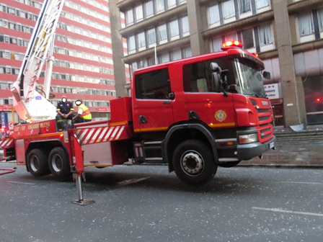
Picture 1: Hydraulic Platform based in Kempton Park

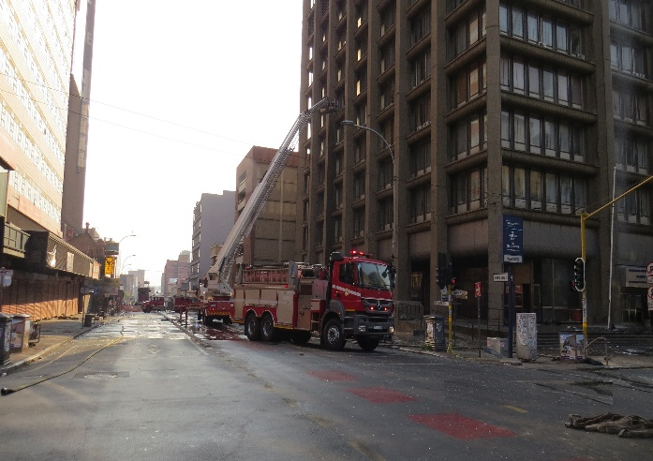
Picture 2: Type of water tanker used

- With regard to water hydrant connections, there are two main types of connections that are used within the Fire Brigade services and these are bayonet type or screw type standpipes. Both types of connection stand-pipes are part of the basic equipment readily available in the fire engines. Bayonet standpipe fits on a bayonet water hydrant outlet and the screw type standpipe is compatible with a screw type system water hydrant. It is important to note that these connections are not marked hence a Firefighter must open the lid and inspect before connecting the correct stand pipe. The correct standpipe was used on the day to sustain relay water supply to the fire through the pumps. Laying out of attack lines was done swiftly because firehoses are pre-packed. Thus, firefighting was initiated immediately on arrival. The CoE, for illustrative purposes has attached pictures of the different types of standpipes as outlined below:
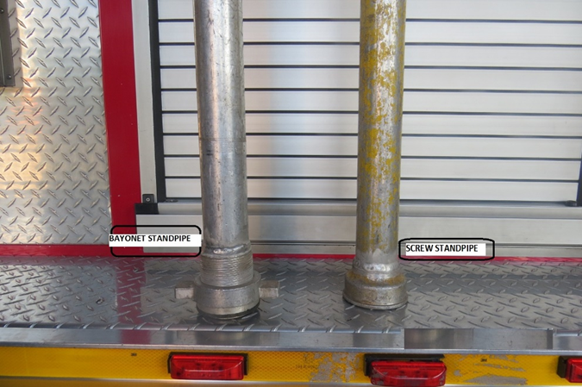
Picture 3: Types of Standpipes

- With regard to the time Firefighters started dousing the flames, it is important to note that upon arrival Firefighters started extinguishing the fire. Firefighters found members of the public busy trying to salvage what they could from the fire. Members of the public were respectfully requested to evacuate the scene for safety reasons during firefighting operations.

- The primary obligation of firefighters is to save lives and property. The DEMS cannot account for the missing equipment (Laptop). The City encourages the complainant to report the matter to the South African Police Services for further investigation.

- There is no need for the Minister to institute an enquiry regarding the response of CoE to this fire incident. From an operational perspective, Standard Operating Procedures were followed for the management of the incident and adequate resources (measured against South African National Standard 10090: Community Protection Against Fire) were deployed to the incident.

- BACKGROUND INFORMATION

The delivery of fire services is supported by various international and national standards. These standards are being used widely in the fire service sector in the country. The primary standard relevant for the provision of fire services is the South African National Standard (SANS) 10090: Community Protection Against Fire. This standard is the primary barometer utilised by most municipalities to measure the performance of fire services. The purpose of this standard is to provide advice on the measures that should be taken to ensure that fire services are efficient. It includes a schedule against which the performance potential of each aspect, as well as of the whole, of a fire service can be judged. A fire-risk rating based on this schedule will indicate the extent to which loss of life and property can be avoided in any particular given area. The SANS 10090 is based on the premise that successful control and extinguishing of fires depend on sufficient appliances responding with adequate manpower and arriving within a reasonable time. It is important to highlight that although most fire services comply with the requirements of this standard, it only becomes applicable once a municipality adopts it as its service delivery standard. The City of Ekurhuleni (CoE) has adopted this standard as its service delivery standard. From the report/ response received from CoE, it is clear that the City complied with the standard in its deployment of firefighters and resources to this incident. In terms of this standard, the weight of response to fires is as outlined below:

Weight of response in terms of SANS 10090: Community protection against fire
1 | 2 | 3 | 4
Risk Category | Minimum number of pumping units | Minimum manning level per appliance | Minimum pumping capacity of each unit (L/min)
A (Central business districts and extensive commercial and industrial areas normally found in cities and large towns (areas where the risk to life and property due to fire occurrence and spread is likely to be high). | 2 | 5 | 3850
B (Limited central business districts, smaller commercial or industrial areas normally associated with small towns and decentralized areas of cities and large towns (areas where the risk to life and property due to fire occurrence and spread is likely to be moderate). | 2 | 4 | 3850
C (Residential areas of conventional construction). | 1 | 4 | 2 250
D (Rural areas of limited buildings and remote from urban areas).  D1 (Houses > 30 m apart)  D2 (Houses 10,1 m – 30 m apart)  D3 (Houses 3 m – 10 m apart)  D4 (Houses < 3 m apart) | 1 | 4 | 2 250
E (Special risk areas. Individual areas requiring a pre-determined attendance over and above the predominant risk category in an area. Includes large shopping/entertainment centres, informal settlements, harbours, hospitals, prisons, large airport buildings and petrochemical plants). | As determined by individual risk assessment
Note: Arrangements for vehicle fires, grass/bush and special services and the need for specialist vehicles such as aerial appliances and water carriers will be determined by local conditions.

Ends…

