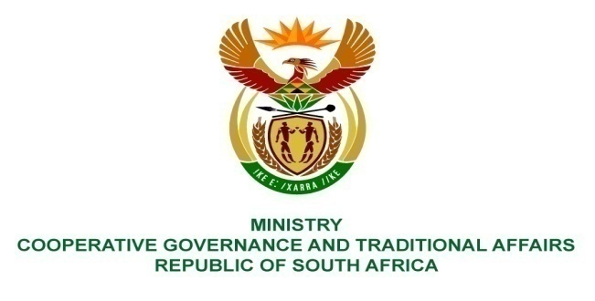
________________________________________________________________________________________

FOR WRITTEN REPLY

NATIONAL ASSEMBLY

PARLIAMENTARY QUESTION NO 2017/601

Ms A Steyn (DA) to ask the Minister of Cooperative Governance and Traditional Affairs:
- Since his reply to question 2365 on November 2016, how many boreholes has (i) his department and (ii) each municipality (aa) drilled and/or installed, (bb) refurbished and/or (cc) equipped
- What were the costs,
- From which departmental (sub) programme was the expenditure funded,
- To which companies were contracts related to the specific borehole activities awarded and
- What is the location of the specified boreholes? NW659E

Reply
- (i) The Department of Cooperative Governance and Traditional Affairs
did not undertake directly.
(aa) any drilling and/ or installation of boreholes
(bb) any refurbishment of boreholes
(cc) any equipping of boreholes.

- According to the information received from the municipalities,
(aa) drilled and/ or installed 33 boreholes
(bb) refurbished 3 boreholes
(cc) equipped no borehole.
Only Mpumalanga and Northern Cape reported information on boreholes completed as indicated in the table below. All other provinces had not completed any work on boreholes since November 2016.
Province | Municipality | a. How many boreholes
 |  | ii (aa). Drilled | ii (bb). Refurbished | ii (cc). equipped
Mpumalanga | Govan Mbeki LM | 24 | 0 | 0
 | Lekwa LM | 6 | 0 | 0
Northern Cape | Ga-Segonyana | 3 | 2 | 0
 | Gamagara | 0 | 1 | 0
TOTAL |  | 33 | 3 | 0
Reference: A detailed list is attached in Annexure A.
(b): (aa) drilling and/ or installation of 33 borehole amounts R 6593 564.21
(bb) refurbishment of 3 boreholes amounts R 299 850.00
(cc) as there was no equipping of boreholes, no cost incurred.
Reference: A detailed list is attached in Annexure A.
(c): Expenditure were funded from MIG of the Department of Cooperative Governance and MWIG of the Department of Water and Sanitation
The details of funding are as given hereunder
(aa) drilling and/ or installation costs of total R 6 593 564.21, MIG provided total R 6 057 499,21 (Mpumalanga got R 6 057 499.21 and Northern Cape got R 264 390.00). MWIG provided the rest R 536 065.00 which went to Northern Cape alone.
(bb) refurbishment costs of total R 299 850.00 was provided by MWIG and Northern Cape got all of it.
(cc) No cost was incurred.
Reference: A detailed list is attached in Annexure A.
(d): The companies to which the contracts were awarded to were:
- M/s Sandmix Construction and Development and M/s Asdu Trading got the contracts for Mpumalanga municipalities and
- M/s Kimopax/ Gobora Drilling AB Pumps Contractors gt the contrats of Northern Cape municipalities
Reference: A detailed list is attached in Annexure A.
(e): The boreholes location details are given in Annexure A.

