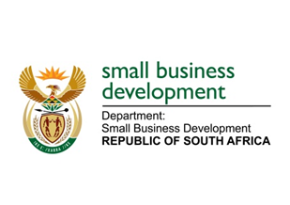
NATIONAL ASSEMBLY

QUESTION FOR WRITTEN REPLY

“600. Mr R W T Chance (DA) to ask the Minister of Small Business Development:

What are the relevant details of the progress made between the (a) Small Enterprise Development Agency and (b) Small Enterprise Finance Agency and the Department of Trade and Industry relating to its black economic empowerment status as accredited providers to the small and medium enterprises sector?”
NW723E

REPLY:

The Department of Trade and Industry (the dti) has published the application for the Small Enterprise Finance Agency’s (sefa) B-BBEE facilitator status for public comment. The latest update from the (the dti) is that responses have been received from the public with no major objections and therefore the facilitator status will be granted. However, the approval to use the facilitator status will be limited to the transformation of financial intermediaries. The final approval is awaiting a go-ahead from the Minister of Trade and Industry.

The Small Enterprise Development Agency (Seda) is in consultation with the the dti regarding a BEE facilitator status and has initiated the BEE verification process. The first verification process was finalised in May 2018 which found Seda to be non-compliant as most of Seda expenditure was not considered as it was core of our business. A second verification is planned to take place in March 2019.

