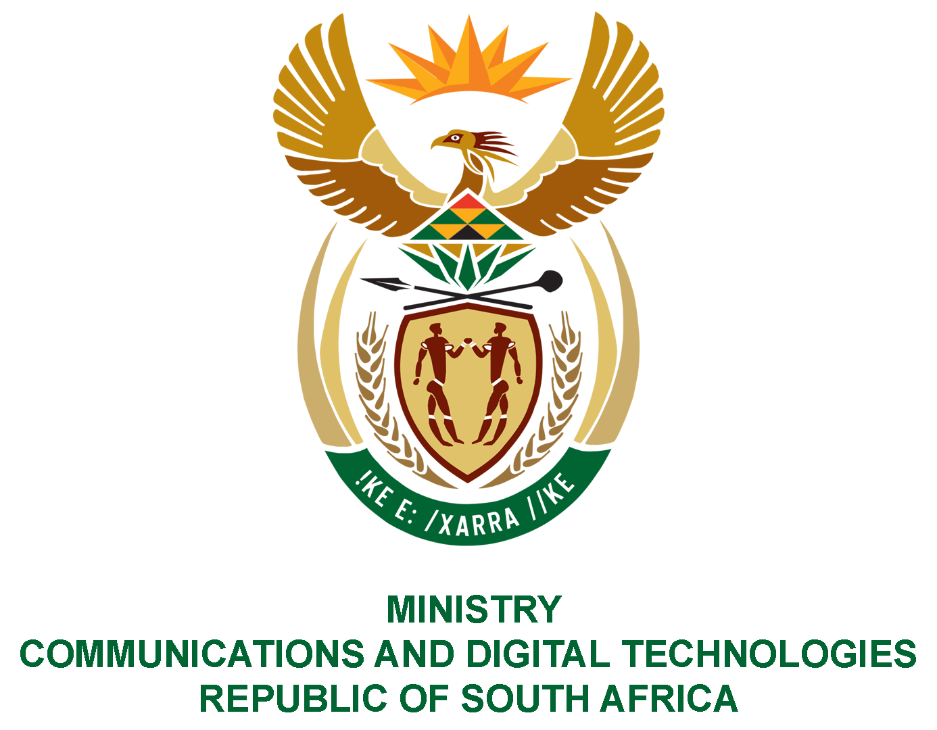

PARLIAMENT OF THE REPUBLIC OF SOUTH AFRICA

NATIONAL ASSEMBLY

WRITTEN REPLY

QUESTION: 60

DATE OF PUBLICATION: 10 FEBRUARY 2022
QUESTION PAPER NO: 01

Mr T W Mhlongo (DA) to ask the Minister of Communications and Digital Technologies:
- Whether she has found that there are enough sports commentators for all indigenous languages on all SA Broadcasting Corporation (SABC) channels; if not, why not; if so, what are the relevant details;

- By what date does her department intend to have (a) Afrikaans and/or (b) isiXhosa and/or (c) isiZulu cricket radio commentaries on the SABC channels;

3. Whether there is a time frame in place of when her department will pursue the idea that we must have all African language sports commentators on SABC channels in all sporting codes; if not, why not; if so, what are the relevant details;

4. By what date(s) will the service of sports commentators in different languages be available on SABC channels?
NW64E
REPLY:
I have been advised by the SABC as follows:

- There are sufficient commentators for all indigenous languages and for all covered sporting codes, even XK FM has started doing live commentary in !Xu and Khwe languages.

- (a,b,c) The SABC has always carried live cricket commentary in the three languages (English, isiXhosa and Afrikaans). This is still in place on the respective radio stations when they carry the games. This is not possible on analogue TV as it cannot do multiple audio tracks. This is possible on the SABC Sport Channel (DTT and DTH) and does occur, but the SABC cannot afford to do this simultaneously at this time.

- This is the specialty of SABC Radio Stations and has been the case for many years. The SABC has identified and groomed most of the country’s sports commentators, who have gone on to work for other industry players.

- This is already in place, but sequentially. This is done in parallel and will only be possible if the costs can be justified and it will be on a ‘case by case basis’. Currently Sport is a loss-making entity due the high cost of sport rights. The SABC is mandated in terms of the sports regulations to prioritise national sporting events. Therefore, it tries its best to ensure that there is a balance of the core language groups used in the broadcast of such events.

MS. NONKQUBELA JORDAN-DYANI
DIRECTOR-GENERAL (ACTING)
DATE:

Recommended/not recommended

__________________________
HON. PHILLY MAPULANE, MP
DEPUTY MINISTER
DATE:

Approved/ not approved

________________________________
HON. KHUMBUDZO NTSHAVHENI, MP
MINISTER
DATE:

