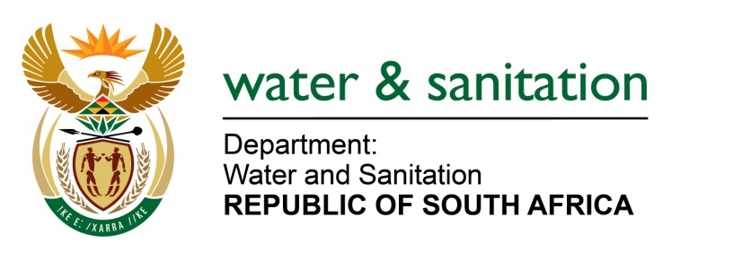

NATIONAL ASSEMBLY

FOR WRITTEN REPLY

QUESTION NO 6

DATE OF PUBLICATION IN INTERNAL QUESTION PAPER: 8 FEBRUARY 2018
(INTERNAL QUESTION PAPER NO. 1)

6. Mr M G P Lekota (Cope) to ask the Minister of Water and Sanitation:
What (a) plans has her department put in place in respect of the augmentation of existing and the development of new bulk water infrastructure to mitigate the effects of climate change on the provision of bulk water in the Western Cape Province and (b) is the status of the (i) plans and (ii) financing thereof? NW7E
---00O00---
REPLY:
(a) My Department is working on the implementation of the Berg River-Voelvlei Augmentation Scheme (BRVAS). This project augments the Western Cape Water Supply System that serves the Cape Town Metropolitan and surrounding smaller urban areas as well as irrigators in the area. In addition to the BRVAS project, various surface water schemes (e.g. the Michell’s Pass Diversion, Further Phases of the Vloevlei Dam Augmentation, Upper Wit River Diversion, Molenaars River Diversion and the Raising of the Lower Steenbras Dam) are at various stages of investigation for further augmentation of the system in the medium- to long-term.
(b)(i) Planning work for the BRVAS project has been concluded and environmental authorisation is expected by May 2018, if there are no snags with appeal process. However, considering the severe drought situation prevailing in the region, I have whilst awaiting the approval or finalization of the environmental authorization appointed the Trans-Caledon Tunnel Authority (TCTA) to secure funding and implement the project on a fast-track basis. The TCTA is currently engaging the City of Cape Town and other potential users of the water to finalize off-take agreements.
(b)(ii) The TCTA is currently engaging the National Treasury to obtain approval on a funding mechanism and the required guarantees.
---00O00---

