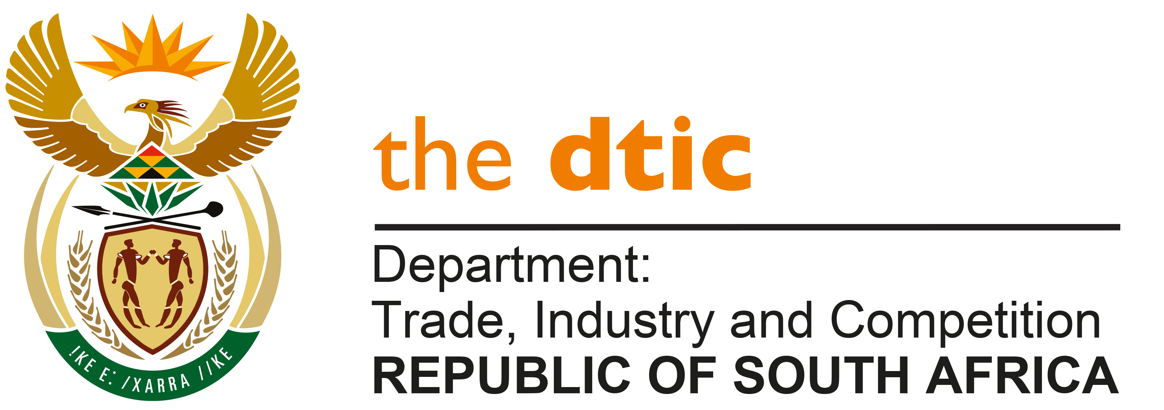

THE NATIONAL ASSEMBLY

QUESTION FOR WRITTEN REPLY

QUESTION NO. 598

PUBLISHED: 26 FEBRUARY 2021

MP Inkosi R N Cebekhulu (IFP) to ask the Minister of Trade and Industry

What total number of (a) applications for the South African Film and Television incentives has his department received since the reopening in August 2020 and (b) the specified applications have been granted? [NW654E]

REPLY

- I have been advised by the department that sixty-six (66) applications were received under the South African Film and Television incentives since the reopening in August 2020.

- Twenty-seven (27) compliant applications have been adjudicated and thirty-one (31) non-compliant applications were returned back to clients in line with the scheme guidelines. Eight compliant applications are ready for adjudication at the next committee meeting.

-END-

