THE NATIONAL ASSEMBLY

QUESTIONS FOR WRITTEN REPLY

QUESTION NO. 595

Mrs Y N Yako (EFF) to ask the Minister of Trade and Industry:

(a) What percentage of black women-owned businesses does the Industrial Development Corporation fund, (b) in what sectors are the women-owned businesses and (c) how does the specified percentage compare with the other demographics? NW786E

RESPLY

I have been provided with the following reply by the IDC:

- & (c)
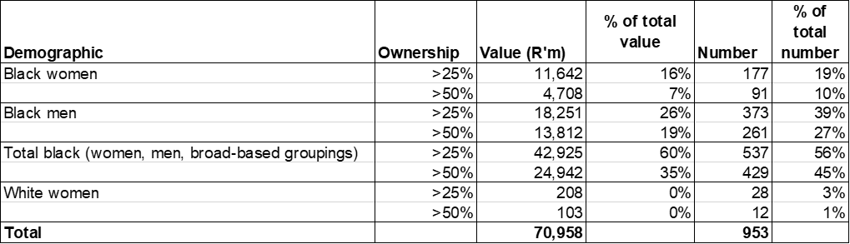

(b)
Black women
Sector | Value of approvals (R'm) |  | Number of approvals
 | >25% | >50% | >25% | >50%
Agro Processing & Agriculture | 324 | 66 | 14 | 6
Basic Metals and Mining | 5,643 | 1,847 | 15 | 6
Clothing & Textiles | 121 | 4 | 18 | 5
Basic & Speciality Chemicals | 725 | 508 | 13 | 8
Chemical Products & Pharmaceuticals | 204 | 66 | 17 | 10
Machinery & Equipment | 948 | 635 | 20 | 12
Automotive & Transport Equipment | 684 | 356 | 14 | 8
Heavy Manufacturing | 459 | 202 | 21 | 9
Light Manufacturing & Tourism | 1,030 | 699 | 19 | 13
Industrial Infrastructure | 808 | 127 | 11 | 5
Media and Audio Visual | 585 | 89 | 12 | 6
Other | 110 | 110 | 3 | 3
Total | 11,642 | 4,708 | 177 | 91

(c)
Refer to above.

____________________
Mr L October
Director-General: Department of Trade, Industry and Competition (the dtic)
_____/_____/2020

Supported / Not Supported

____________________
Mr E Patel
Minister of Trade, Industry and Competition
____/____/2020

Approved / Not Approved

