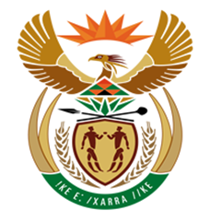

NATIONAL ASSEMBLY
QUESTION FOR WRITTEN REPLY
QUESTION NUMBER: 591 [NW649E]
DATE OF PUBLICATION: 17 MARCH 2017

591. Mr D J Maynier (DA) to ask the Minister of Finance:
(1) Whether the release of the press statement attacking Judge Dennis Davis, head of the Davis Tax Commission, issued by the SA Revenue Service on 10 March 2017, was authorised by (a) himself and/or (b) the SA Revenue Service Commissioner, Mr Tom Moyane; if not, in each case, why not; if so, in each case, why;
(2) whether he will make a statement on the matter?
NW649E
REPLY:

- (a) I was not the Minister of Finance on the 10th of March 2017,

(b) Yes, the statement was authorised by the Commissioner for the South African
Revenue Service.

- Not applicable.

