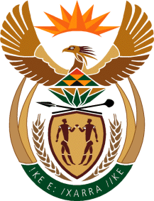

MINISTER IN THE PRESIDENCY: REPUBLIC OF SOUTH AFRICA
Private Bag X1000, Pretoria, 0001, Union Buildings, Government Avenue, PRETORIA
Tel: (012) 300 5200, Website: www.thepresidency.gov.za

NATIONAL ASSEMBLY
WRITTEN QUESTION FOR WRITTEN REPLY

QUESTION NUMBER: 590
DATE OF PUBLICATIONS: 26 February 2021

590. Ms Z Majozi (IFP) to ask the Acting Minister in the Presidency

Whether she has been informed of a high-level operation in which powerful politicians are using state organs in an attempt to harm Independent Media and its major shareholder, Sekunjalo Investment Holdings, thereby posing a threat to media freedom (details furnished); if not, why not; if so, what is her department’s position on the matter? NW646E.

REPLY:
The GCIS is not aware of any operation to harm the Independent Media Group and its major shareholder Sekunjalo Investment Holdings. The department is obliged in terms of the Constitution of the Republic of South Africa to treat all media fairly.

Thank You.

