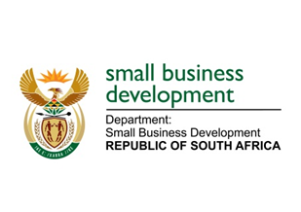
NATIONAL ASSEMBLY
QUESTION FOR WRITTEN REPLY
DUE TO PARLIAMENT: FRIDAY, 18 MARCH 2022

588. Mr F Jacobs (ANC) to ask the Minister of Small Business Development:
(1) Given that small-, medium- and micro enterprises (SMMEs) based in Cape Town under a certain intermediary (name furnished) did not provide employment contracts and/or accurate financial supporting documents deviating from Small Enterprise Finance Agency processes, who will hold management accountable for proper facilitation of jobs obtained through SMMEs employment contracts in the Western Cape;
(2) whether she has found that the Department of Labour can intervene in the specified case; if not, why not; if so, what are the relevant details? NW656E

REPLY: I have been advised by the department as follows:

- Reporting of jobs created and maintained by a respective financial Intermediary is furnished by the Financial Intermediary through capturing such information on the Small Enterprise Finance Agency (sefa) Intermediary portal. The legal agreement between the sefa and the financial Intermediaries requires the financial Intermediaries to have supporting documents to support their developmental information (such as, application forms, FICA documents and signed contractual agreement between SMME and the Financial Intermediary) for verification by sefa and its external auditors.

The information is captured, verified and approved by the respective financial Intermediary before sefa authorises it on the system. It is therefore the Intermediary’s responsibility to ensure that correct and reliable information is shared with sefa

- sefa has not picked up any inaccurate financial reports nor a claim or complaint of such that could have required intervention. sefa hereby confirms that the said financial Intermediary has repaid the facility in full, both Capital and Interest advanced under the agreement. The last payment received was on 12 October 2020. The relationship between sefa and the financial Intermediary ended when the loan was fully amortised.

STELLA NDABENI-ABRAHAMS
MINISTER: SMALL BUSINESS DEVELOPMENT

