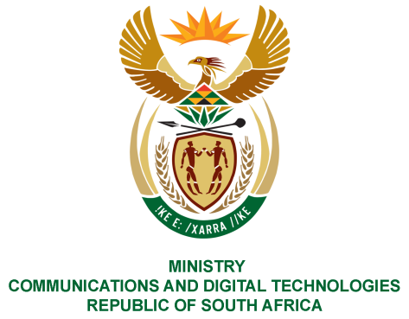
PARLIAMENT OF THE REPUBLIC OF SOUTH AFRICA
NATIONAL ASSEMBLY
WRITTEN REPLY

QUESTION NO: 587
DATE OF PUBLICATION: 3 March 2023
QUESTION PAPER NO: 06

Ms. D Kohler (DA) to ask the Minister of Communication and Digital Technologies
- Whether she will provide clarity on her Postbank activation drive to Struisbaai where decoders and televisions were handed out; if not, why not, if so, what (a) total number of televisions and decoders were handed out and (b) was the total cost of each television and decoder.

- What (a) total number of individuals that they interacted with signed up for Postbank services and (b) are the relevant details of the (i) project partners and (ii) terms and conditions of the specified deal?

NW658E
Reply

- The Postbank has been on a countrywide drive to promote its service offerings as it gets ready to play the role of a State Bank. Additional to the support provided to the Postbank at Struisbaai, the former Minister conducted oversight monitoring of the distribution of decoders by SAPO and installation thereof by Sentech to registered households towards fulfilling ConCourt judgement of June 2022.

- Decoders were distributed to qualifying registered households and five (5) 32 Inch Integrated Television sets were donated to deserving poor households.
- The cost of the IDTV is estimated at R3500.

- (a) Through this activation, the Postbank generated 429 leads (individuals who provided their contact information for marketing/ solution purposes). The leads are being analysed and engaged for conversion by the acquisition team.
- This was exclusively a Postbank initiative from an execution standpoint. The campaign was part of Postbank’s ongoing brand and product awareness efforts and to also promote financial literacy and education as part of Postbank founding mission.

Thank You.

