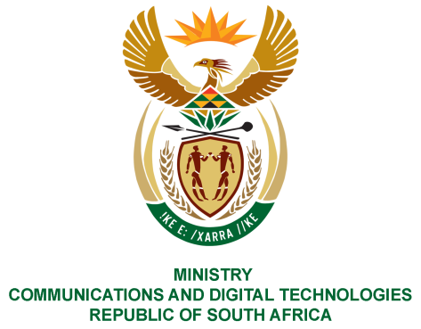
PARLIAMENT OF THE REPUBLIC OF SOUTH AFRICA
NATIONAL ASSEMBLY
WRITTEN REPLY

QUESTION NO: 585
DATE OF PUBLICATION: 3 March 2023
QUESTION PAPER NO: 06

Ms. D Kohler (DA) to ask the Minister of Communication and Digital Technologies
1. With reference to amounts owed by the SA Post Office (SAPO) to their medical aid (Medipos) on behalf of its employees, what (a) total amounts are currently owed by SAPO to Medipos and (b) are the further, relevant details in this regard;
2. (a) what are the relevant details of the amount(s) owed to Medipos that have been written off by SAPO and/or intends to be written off by SAPO and (b) which person(s) and/or member(s) of the board of trustees took the decision to write off the specified amounts?
NW656E
Reply

- (a) A total amount of R561,667,106 is currently owed to Medipos.
(b)This amount is historical debt, there is no current amount outstanding, SAPO is up to date with Medipos payments.

- (a) No amounts have been written off by SAPO. SAPO has previously requested the Medipos members to consider writing off the historical debt owed.

(b) No decision to write off any amounts has been taken. Currently Medipos has been placed under curatorship.

Thank You.

