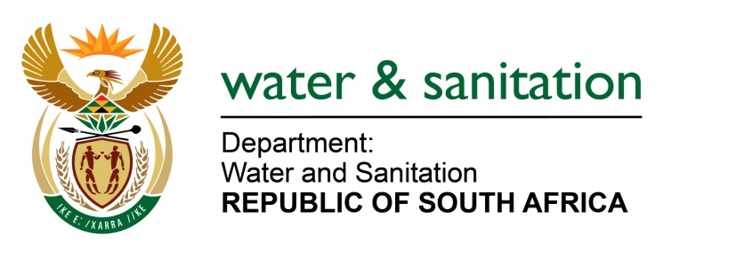

MINISTER OF WATER AND SANITATION

FOR WRITTEN REPLY

QUESTION NO 585

DATE OF PUBLICATION IN INTERNAL QUESTION PAPER: 4 MARCH 2022
(INTERNAL QUESTION PAPER NO. 6)

585. Ms A M Siwisa (EFF) to ask the Minister of Water and Sanitation:

With reference to the project that was started in Sol Plaatjie Local Municipality in Ward 17 to eradicate tin sheltered toilets and build solid structures, which has stopped currently with some residents left with half-built toilets, (a) what are the reasons that the project was stopped and (b) on what date is it envisaged that the project will resume?

NW643E
---00O00---

MINISTER OF WATER AND SANITATION

The construction of toilet top structures in Kutlwanong, Kagisho and Phomolong within the Sol Plaatje Local Municipality was funded by the Department of Water and Sanitation and implemented by the Sol Plaatje Local municipality.

The municipality appointed Makone Consulting Engineers as the consulting engineers and Renaissance Skills Centre as the contractor for the construction of 320 toilet top structures. Construction commenced on 24 March 2021 and was anticipated to be completed by 22 November 2021. However, delays were encountered due to non-payment of labourers by the contractors which resulted in labour unrest and works stoppages.

The contractor submitted a request for extension of time, which was not approved by the Municipality. The Municipality has committed to completing the remaining works utilising internal resources. It is anticipated that the project will be completed by end June 2022.

---00O00---

