NATIONAL ASSEMBLY
36/1/4/1(201900076)

FOR WRITTEN REPLY QUESTION 584
DATE OF PUBLICATION IN INTERNAL QUESTION PAPER: 8 MARCH 2019 (INTERNAL QUESTION PAPER NO 7-2019)

584. Ms D Kohler (DA) to ask the Minister of Police:

What is the status of the investigation intD CAS 415/8/2018 opened at the Lyttleton Police Station?
NW707E
REPLY:

The abovementioned case is belng investigated by the Pretoria Serious Commercial Crime Unit. Certain warning statements and witness statements are being sought by the investigating officer.

Reply to question 584 recommended/

CO
LE (SOEG)
GENERAL NER: TH AFRICAN POLICE SERVICE

Reply to question 584 appro\/9d

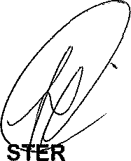
MINI
OF POLICE
BH CELE, MP

