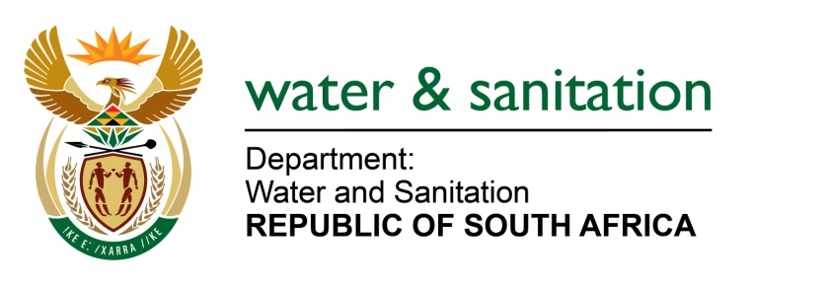

NATIONAL ASSEMBLY

FOR WRITTEN REPLY

QUESTION NO 582

DATE OF PUBLICATION IN INTERNAL QUESTION PAPER: 10 MARCH 2017
(INTERNAL QUESTION PAPER NO. 9)
582. Mr C D Matsepe (DA) to ask the Minister of Water and Sanitation:

(a) What is the total amount owed by her department to all relevant contractors as at 28 February 2017 and (b) in each case, (i) what is the name of the contractor, (ii) what amount is outstanding and (iii) on what date will the amounts be paid? NW641E
---00O00---
REPLY:

Kindly refer to the presentation provided to the Portfolio Committee on Water and Sanitation on 03 March 2017 by the Department of Water and Sanitation for details of supplier invoices and the reasons for non-payment.
---00O00---

