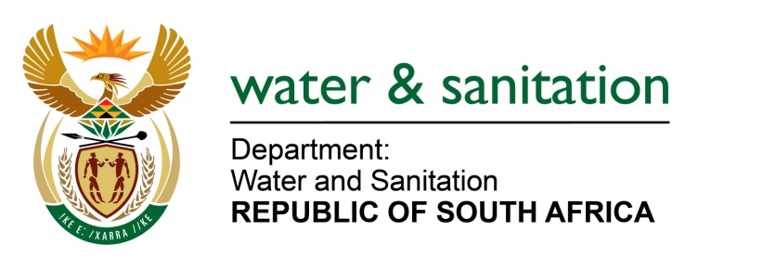

NATIONAL ASSEMBLY

FOR WRITTEN REPLY

QUESTION NO 581

DATE OF PUBLICATION IN INTERNAL QUESTION PAPER: 10 MARCH 2017
(INTERNAL QUESTION PAPER NO. 9)
581. Mr L J Basson (DA) to ask the Minister of Water and Sanitation:

(a) What is the total amount owed by her department to the 15 water boards as at 28 February 2017 and (b) in each case, (i) what is the name of the water board owed, (ii) what amount is outstanding and (iii) on what date will the amounts be paid? NW639E
---00O00---
REPLY:
(a) The total amount owed by the Department to the water boards as at 28 February 2017 amount to R 482 055 862.36
(b) The name of the Water board, amount outstanding and when the amount will be paid is detailed in Annexure A attached.
---00O00---

