QUESTION 580

DATE OF PUBLICATION IN INTERNAL QUESTION PAPER: 8 MARCH 2019 (INTERNAL QUESTION PAPER NO 2-2019)

36/1/4/1(2019)
NATIONAL ASSEMBLY

FOR WRITTEN REPLY

QUESTION 580

DATE OF PUBLICATION IN INTERNAL QUESTION PAPER: 8 MARCH 2019 (INTERNAL QUESTION PAPER NO 580)

W702E: 580. Mr Z N Mbhele (DA) to ask the Minister of Police:

- On what date will the final report of the panel of experts that flowed from the Farlam Commission be released publicly and (b) what are the key (i) findings and (ii) recommendations of the panel’s report? NW703E
Answer

The Minister will release the report in due course, and,
- (i) findings will be released when the report is made public
(ii) Recommendations will also be tabled when the report is publicized.

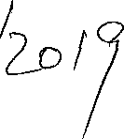
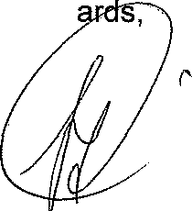
Ministér of Police BH Cele ) Date:
Kind reg

