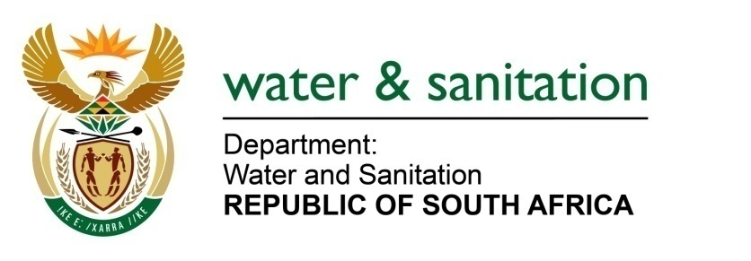

NATIONAL ASSEMBLY

FOR WRITTEN REPLY

QUESTION NO 580

DATE OF PUBLICATION IN INTERNAL QUESTION PAPER: 10 MARCH 2017
(INTERNAL QUESTION PAPER NO. 9)
580. Mr L J Basson (DA) to ask the Minister of Water and Sanitation:
(1) With reference to her department’s comments in a presentation to the Portfolio Committee on Water and Sanitation on 1 March 2017 that North West still needs support, (a) how will her department assist with the (i) training and (ii) monitoring of workers and (b) on what date will her department commence with training;
(2) (a) where did her department withdraw tankers and (b) why were the tankers withdrawn? NW638E
---00O00---
REPLY:

(1)(a) The Department will assist in registering the process controllers on the Blue Drop System (BDS) for potable water and Green Drop System (GDS) for waste water, both are web-based systems used as regulatory tools by the Department. The process controllers will be registered on the BDS and/ or GDS taking into account their years of experience operating the treatment facilities and relevant qualifications in water or wastewater treatment. Upon completion of the training WSAs will load the recently acquired certificate and the Department approves the process controller to a relevant class based on qualification/s and years of experience and issues a certificate which will indicate the class of a process controller. This will assist in identification of level of compliance of process controllers against the water treatment facilities requirements and further training needed in order for the process controllers to be at the required skills for the treatment facility they operate.

The Local Government Sector Education Training Authority (LG SETA) in collaboration with the Department has just started the process of registering learners (process controllers) in preparation for the implementation of the Recognition of Prior Learning programme for employees working in the water and waste water treatment works.

The programme will be implemented in 7 WSAs, which are Dr Ruth Segomotsi Mompati District Municipality, Madibeng Local Municipality, Moses Kotane Local Municipality, Moretele Local Municipality, Ventersdorp Local Municipality and Kgetlengrivier Local Municipality and City of Matlosana Local Municipality. During 2016/17, the Department piloted a groundwater monitoring training for borehole pump operators in the following three Water Services Authorities: Moretele Local Municipality, Ngaka Modiri Molema District Municipality and the Madibeng Local Municipality. The training programme has been developed to enhance monitoring of groundwater levels by the Water Services Authorities to ensure continuous availability of groundwater within their area of jurisdiction.

(1)(b) The training is envisaged to start on 01 April 2017.

(2) The Water tankers were withdrawn on the 31 January 2017 from the North West, Free State and Eastern Cape Provinces’ municipalities which were affected by drought.
---00O00---

