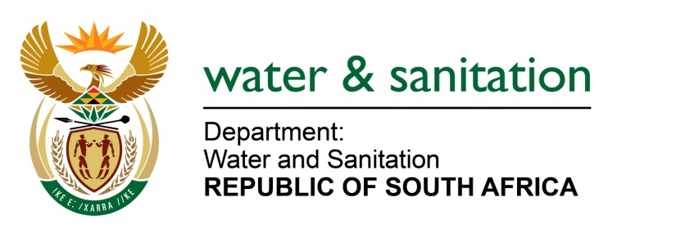

NATIONAL ASSEMBLY

FOR WRITTEN REPLY

QUESTION NO 579

DATE OF PUBLICATION IN INTERNAL QUESTION PAPER: 10 MARCH 2017
(INTERNAL QUESTION PAPER NO. 9)
579. Mr L J Basson (DA) to ask the Minister of Water and Sanitation:
(1) With reference to her department’s comments in a presentation to the Portfolio Committee on Water and Sanitation on 1 March 2017 that North West still needs support, (a) how does her department intend to support the (i) Ngaka Modiri Molema District Municipality and (ii) Dr Ruth Segomotso Mompati District Municipality with the supply of water and sanitation services, (b) who will be responsible for the implementation of the support and (c) when will the implementation commence;
(2) (a) how will her department resolve the problem of the (i) empty Wentzel Dam and (ii) lack of funds and (b)(i) when will each specified problem be resolved and (ii) which entity will be responsible for solving each problem? NW637E
---00O00---

REPLY:

(1)(a)(i) I have issued a directive in terms of Section 41 (1) (a) (ii) of the Water Services Act and Section 73 (1) (d) to Sedibeng Water to carry over the operation and maintenance within the Ngaka Modiri Molema District Municipality (DM). At the moment, all local municipalities under the Ngaka Modiri Molema DM receive support from Sedibeng Water Board as the Water Service Provider. My Department has also appointed Sedibeng Water Board as the Implementing Agent for implementation of the Regional Bulk Infrastructure Programme and Water Services Infrastructure Programme in support of the provision of water and sanitation service delivery with a budget of R780 Million over the MTEF period.

(1)(a)(ii) My Department has allocated funding to the tune of R1,244 billion under Regional Bulk Infrastructure Programme and the total amount of R 77 million through the Water Services Infrastructure Programme in support of the provision of water and sanitation service delivery in Dr Ruth Segomotsi Mompati DM over the MTEF period.

(1)(b) My Department has also appointed Dr Ruth Segomotsi Mompati DM as the Implementing Agent and therefore will be responsible for the implementation of the latter support.

(1)(c) The work is envisaged to commerce in June 2017.

(2)(a)(i) During the financial year 2016/17, my Department through the National Water Resources Infrastructure (Construction West Unit) has rehabilitated the portion of the Wentzel Dam on the foundation for stabilization, fitting of the piece of a steel pipe and couplings to ease the maintenance. This work has already reduced loss of water through redundant structures and leaking valves. Since the dam is currently at full capacity, immediately when the dam level is low, my Department will resume with the removal of the silt in order to increase its capacity .The construction of the bulk pipeline from Bloemhof to augment the water supply in Schweizer Reneke will also commence in 2018 with the intention to complete the project within a year .The project cost on the pipeline is R222 million which will also bring relief to Wentzel Dam.

(2)(a)(ii) In the current financial year 2017/18, my Department has allocated R14 Million under Water Services Infrastructure Grant (WSIG) for the refurbishment of the Water Treatment Works and for the implementation of the Water Conservation and Water Demand Management programme in Schweitzer-Reneke.

(2)(b)(i) The project for the refurbishment of the Water Treatment Works and for the implementation of the Water Conservation and Water Demand Management programme in Schweitzer-Reneke is anticipated to be completed by end of June 2018.

(2)(b)(ii) The Dr Ruth Segomotsi Mompati as the Water Services Authority and as the Implementing Agent will be responsible for the implementation of this project.

---00O00---

