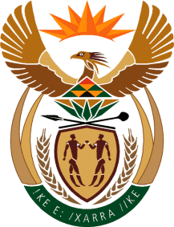

MINISTRY OF TOURISM
REPUBLIC OF SOUTH AFRICA

Private Bag X424, Pretoria, 0001, South Africa. Tel. (+27 12) 444 6780, Fax (+27 12) 444 7027
Private Bag X9154, Cape Town, 8000, South Africa. Tel. (+27 21) 469 5800, Fax: (+27 21) 465 3216

NATIONAL ASSEMBLY:

QUESTION FOR WRITTEN REPLY:
Question Number: 573
Date of Publication: 26 February 2021
NA IQP Number: 4
Date of reply: 01 April 2021

Ms H S Winkler (DA) to ask the Minister of Tourism:
(1) Whether her department has established what percentage of tourism can be attributed to eco-tourism annually for the past five years; if not, why not; if so, what are the relevant details;
(2) (a) what growth has been identified in eco-tourism since the inception of the Green Tourism Incentive Programme (GTIP) and (b) will the growth be plotted annually since the GTIP inception? NW629E

REPLY:
- No, the department does not collect statistics under a category called eco-tourism. Department monitors the tourism sector’s performance through classified industries related to the Tourism Satelite Account as per System of Industrial Classifications. These include, accommodation, food and beverages, transportation, travel agencies and other reservation services, cultural industries, sports and recreational industries, and retail trade (tourism connect goods). This is an approach that is followed worldwide, including by National Statistical agencies and the UNWTO in the measurement of the sector’s performance and provides standardisation of economic data and comparability thereof.

(2) (a) and (b) GTIP is not an eco-tourism focused incentive. It provides businesses with grant support for energy and water efficiency technology, including retro-fitment. Thus, there is no direct relationship between eco-tourism and the Green Tourism Incentive Programme.

