FOR WRITTEN REPLY
auEsziox sro

NATIONAL ASSEMBLY
36/1/4/1(201900064)

DATE OF PUBLICATION IN INTERNAL QUESTION PAPER: 8 MARCH 2019 (INTERNAL QUESTION PAPER NO 7-2019)

570. Mrs A M Dreyer (DA) to ask the Minister of Police:

- (a) What is the status of CAS 149/7/2014 reported at the EdenVale Police Station and (b) who 1s the investigating officer;

- what are the reasons that the victim has had to wait over three years without the case being finalised†
NW693E
REPLY:

(1)(a) On 6 March 2019, the case was taken to the Senior Public Prosecutor (SPP) for a decision.

(1)(b) In the interest of the case being investigated without fear or favour, the particulars of the investigating officer cannot be divulged.

(2) On 15 July 2014, the suspect was arrested and the case was taken to court for the first appearance. On 28 August 2014, the court requested that the complainant and the accused was to appear for mediation, as it was a common assault case. The complainant refused, stating that he wanted to be compensated.

On 7 November 2014, the matter was withdrawn by the SPP. The case was closed and filed. The complainant was informed and was dissatisfied with the SPP's decision.

On 22 July 2015, the docket was reopened on request of the complainant. On 21 October 2015, the complainant met with the Station Commander and the Detective Branch Commander, after which the case was closed.

On 2 December 2015, the case was reopened. On 3 February 2016, the complainant met with the SPP, where the complainant informed the SPP that

there was a witness to the assault, thereby resulting in a witness statement being taken. The case docket was taken to the SPP for a decision. The case was withdrawn again and filed at the police station.

On 26 July 2018, the case was reopened and sent to the Independent Police Investigative Directorate {lPlD), as the complainant was still dissatisfied. The docket was then sent to the Director of Public Prosecution (DPP) and a decision was made to issue a summons against the accused. On 28 November 2018, the case was before the court and remanded to 13 December 2018. On 13 December 2018, the case was again remanded to 21
January 2019.

On 30 January 2019, the accused passed away. The death certificate was obtained and the docket is currently with the SPP, at the Germiston Magistrate’s Court, for a decision.

Reply to question 570 recommended d

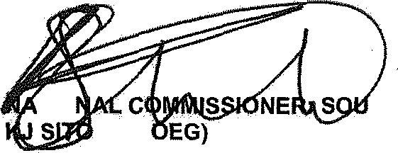
GENERAL AFRICAN POLICE SERVICE
TIO
TH
LE (S

Date: /§]g -t3- 2 f

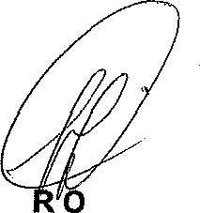
Reply to question 570 appro\lead

MINISTE F POLICE BH CELE, M

