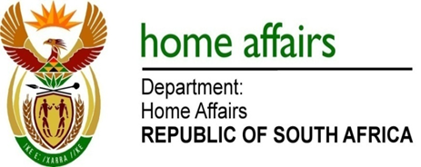

NATIONAL ASSEMBLY

QUESTION FOR WRITTEN REPLY

QUESTION NO. 568

DATE OF PUBLICATION: 8, FRIDAY, MARCH 2019

INTERNAL QUESTION PAPER 7 OF 2019

568. Mr M Waters (DA) to ask the Minister of Home Affairs:

- What (a) are the reasons that the votes cast by South Africans living in Canada in the 2014 national election were not counted and included in the final result and (b) steps is his department taking to ensure that this does not reoccur;

- what total number of other countries where South Africans voted were not counted in the 2014 national election;

- What number of votes were cast by South Africans at each specified overseas voting station in the 2014 national election?
NW691E

REPLY:

I have been informed by the Electoral Commission as follows:

(1)(a) The ballots cast at the Toronto mission in Canada arrived in the Republic after counting of votes had been concluded and the determination of the election results finalised. The late arrival arose, in part, as a result of the delays encountered with ballot packages being cleared at the Canadian customs. In addition, the impact of the International Workers Day holiday on 1 May on the operations of courier companies caused additional delays.

(1)(b) The date for South Africans to vote by special votes abroad has been determined for 27 April 2019 in the election timetable. This means that voting abroad will take place ten (10) days before voting in the Republic and no longer seven (7) days as was the case in 2014 elections. The additional three (3) days will ensure that the cast ballots arrive in time for counting and will avoid the impact of the International Workers Day holiday. Secondly, the Electoral Commission has agreed with the Department of International Relations and Cooperation (DIRCO) on the use of diplomatic channels to transport the cast ballots. This will obviate delays related to custom clearances.

- Three (3) other missions out of a total of hundred and twenty one (121) missions.

- The ballots were not counted. For this reason the votes cast have not been determined. The numbers of approved special votes in each mission are instead provided (this does not necessarily equate to votes cast).

Canada; Toronto [267]
Cuba; Havana [395]
Democratic Republic of Congo; Lubumbashi [11]
Spain; Madrid [78]

