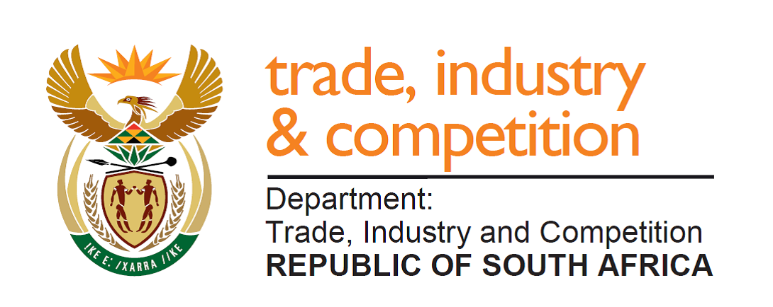

NATIONAL ASSEMBLY

WRITTEN REPLY

PARLIAMENTARY QUESTION 566

DATE OF PUBLICATION: 23 AUGUST 2019

Mr M J Cuthbert (DA) to ask the Minister of Trade and Industry:
(1) Whether there are tariff exemptions on goods imported with the intention of doing humanitarian work; if not, why not; if so, what are the relevant details;
(2) whether there are any (a) provisions within the Southern African Development Community (SADC) and the Southern African Customs Union (SACU) agreements that prevent the tariffs from being removed and (b) future plans within his department to remove tariffs on goods that are intended for humanitarian use; if not, in each case, why not; if so, what are the relevant details in each case? NW1563E

Reply

Provision is made under Schedule 4 of the Customs and Excise Act, 1964, that allows for tariff exemptions on goods imported under certain circumstances, including for charitable and welfare organisations. Attention is drawn on rebate item 405.04 as an example of this. The International Trade Administration Commission (ITAC) administers this provision to ensure that local jobs are not negatively affected and that markets are not disrupted. This is achieved through the application of set criteria.

South Africa is a Member of the Southern African Customs Union (SACU) that establishes a common customs area amongst Botswana, Eswatini, Lesotho, Namibia and South Africa. SACU has a common external tariff for imports coming into common customs area, and goods within SACU circulate freely without any tariffs. Changes to the external tariff – either increases or reductions - can be effected through the due process established under South Africa’s International Trade Administration Act. Nothing in the SACU Agreement prevents tariffs from being removed following the agreed process under the Act.

In terms of the Trade Protocol in the Southern African Development Community (SADC), over 99% of goods imported from the other SADC countries that are party to the SADC Trade Protocol enter South Africa/SACU free of any duty if those goods meet the terms of the agreed rule of origin.

Provision is already made for the rebate of duty for goods imported for humanitarian use. I am advised that the department currently has no plans to make any changes to this dispensation.

-END-

