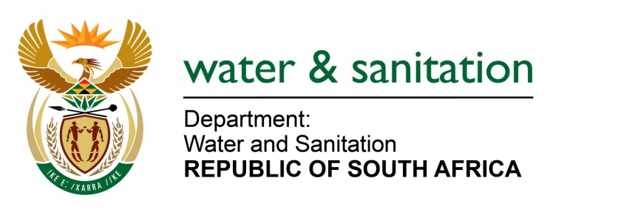

NATIONAL ASSEMBLY

FOR WRITTEN REPLY

QUESTION NO 562

DATE OF PUBLICATION IN INTERNAL QUESTION PAPER: 3 MARCH 2023
(INTERNAL QUESTION PAPER NO. 6)

562. Ms M L Pietersen (ANC) to ask the Minister of Water and Sanitation:
(a) What is the total number of historically disadvantaged persons and communities that have benefited from water use licences in terms of geographical spread issued by his department and (b) in which provinces has his department issued the highest number of licences?
NW622E
MINISTER OF WATER AND SANITATION

- The total number of licences issued to historically disadvantaged persons and communities is as follows:

REGIONAL OFFICE | NUMBER OF HDI’S ISSUED WITH LICENCES
Eastern Cape | 197
Free State | 19
Gauteng | 5
KwaZulu-Natal | 1388
Limpopo | 647
Mpumalanga | 113
North West | 27
Northern Cape | 46
Western Cape | 8
Grand Total | 2450
- KwaZulu-Natal province is where the highest number of licences were issued to Historically Disadvantaged Individuals.

---00O00---

