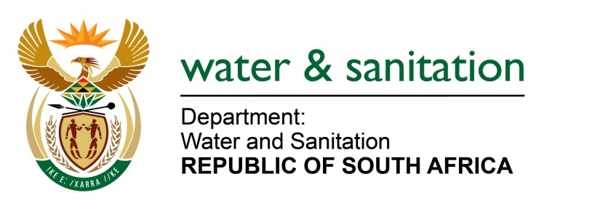

NATIONAL ASSEMBLY

FOR WRITTEN REPLY

QUESTION NO 554

DATE OF PUBLICATION IN INTERNAL QUESTION PAPER: 3 MARCH 2023
(INTERNAL QUESTION PAPER NO. 6)

554. Mr N G Myburgh (DA) to ask the Minister of Water and Sanitation:
What (a) was the total cost of the interventions of his department to mitigate the disastrous consequences of the delivery of water and sanitation by poorly run municipalities since 1 January 2020 and (b) steps has his department taken to hold any persons accountable who have been found responsible for the conditions which prompted the intervention?
NW607E
---00O00---

MINISTER OF WATER AND SANITATION

a) The total cost of intervention projects is R4.5 billion to date. The cost for the intervention in the Mkhanyakude District Municipality is yet to be confirmed once all the planning has been finalised. The details for other interventions implemented since 2020/21 by the department is indicated below:

Number | Region | Municipality |  | Source of funding | Project Name | Cost R’000
1 | Limpopo | Giyani Local Municipality |  | WSIG | Reticulation of 24 villages | 400,000
2 | KwaZulu Natal | Zululand District Municipality |  | RBIG | Mandlakazi Bulk Scheme phase 5 (Esiphambanweni phase 5 & 6) | 400,000
3 | KwaZulu Natal | Ugu District Municipality |  | WSIG | Water Demand & Water Conservation Management | 150,000
4 | KwaZulu Natal | uMkhanyakude District Municipality |  | WSIG | Water Service Projects | TBC
5 | Gauteng | Mogale City |  | WSIG | Emergency WSIG Projects | 180,000
6 | Northwest | Ramotshere Moiloa (Dinokana) |  | WSIG | Dinokana | 30,000
7 | Free State | Maluti-a-Phofung Local Municipality |  | RBIG | Maluti-a-Phofung LM Intervention | 1,837,000
8 | Mpumalanga | Lekwa Local Municipality |  | RBIG | Lekwa Waster Services (Re-purposing/Operations) | 1,016,315
9 | Free State | Matjhabeng Local Municipality |  | RBIG | Matjhabeng bulk sewer (Welkom) | 522,500
 |  |  | Total |  |  | 4,535,815

b) Municipalities are responsible for acting against their personnel. The department has put measures in place to ensure that interventions are implemented effectively and efficiently. Some of the Water Boards such as Umgeni water and Lepelle Northern Water have been appointed to ensure that interventions are implemented in accordance with intended outcomes. The department is continuously monitoring the progress of the implementation and the impact thereof.

Furthermore, the Department ensures the protection of water resources by serving suspected transgressors or municipalities with Notices and Directives in accordance with the provisions of the National Water Act (Act 36 of 1998) (NWA). This is to compel responsible municipalities to take rectification measures on non-compliance cases identified. These Notices and Directives instruct the identified transgressors to make representations, which may take the form of action plans in other instances. Subsequently, the Department assess the representations submitted and advise on the implementation thereof. The Department then monitors implementation of the action plans and ensure adherence to the timeframes committed in order to control the causes of pollution and remedy effects thereof.
Lastly, the Department may institute criminal charges aimed at holding a municipality liable for offenses stipulated under Section 151 of the NWA, whereby fines or imprisonment may be imposed against an offender. The Department may also institute civil action by applying for a court interdict against a municipality. The court may then order the municipality to take remedial action through a Court Order.

The table below depitcs administrative, criminal and civil actions taken to protect water resources against municipalities found to have contravened the provisions of the National Water Act.

---00O00---

