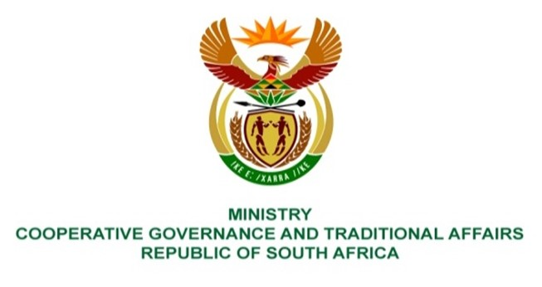

NATIONAL ASSEMBLY
QUESTION FOR WRITTEN REPLY

QUESTION NUMBER 552
DATE OF PUBLICATION: 25 FEBRUARY 2022

QUESTION
552: Mrs S M Mokgotho (EFF) to ask the Minister of Cooperative Governance and Traditional Affairs:
In light of the fact that the Moses Kotane Local Municipality incurred fruitless and wasteful expenditure of R2 822 000 and R111 943 868 which was incurred in respect of prior years and have not yet been dealt with in accordance with section 32 of the Public Finance Management Act, Act 1 of 1999, what (a) steps does she intend to take to assist the municipality to bring the officials who misappropriated public funds to book and (b) are the time frames in this regard? NW620E
REPLY:
The Department coordinated the Municipal Structures Amendment Act of 2021, the Act now includes the function of Municipal Public Accounts Committee (MPAC), which empowers the committee (MPAC) to investigate and report to council on matters affecting the municipality.
The Department is embarking on the development of online monitoring and reporting tool for MPACs. The Department in collaboration with stakeholders within local government space continues to capacitate MPACs to have a better understanding of their oversight role, which includes treatment of unauthorised, irregular, fruitless and wasteful expenditure in accordance with section 32 of Municipal Finance Management Act.
The Northwest Province has targeted to support all four district municipalities on the investigation of unauthorised, irregular, fruitless and wasteful expenditure in line with District Development Model. Additionally, the Provincial CoGTA in collaboration with Provincial Treasury and SALGA will follow up on the work executed by the previous council on the investigation of UIF&W expenditure.
The province has inducted newly elected MPAC members on numerous components with emphasis on investigation and reduction of the UIF&W expenditure in the municipalities on the 7-11 February 2022.
The Department of Treasury is taking a lead on the review of municipal UIF&W expenditure reduction strategy and municipalities are directed to implement the recommendations.

