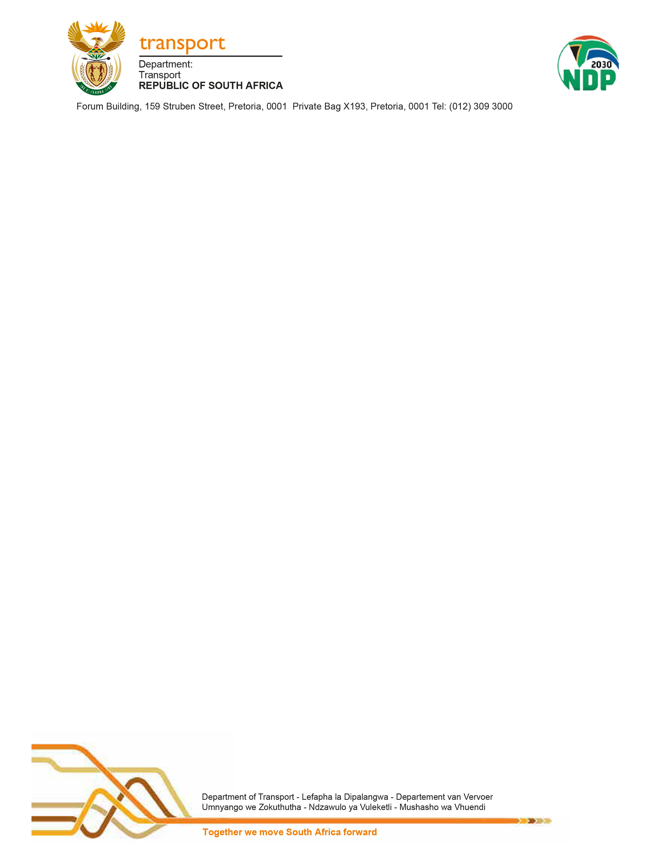

TO: Mr Fikile Mbalula, MP  Minister of Transport | FROM: Mr. Alec Moemi  Director- General
Ms Thandiwe, Mpondo  Parliamentary Liaison Officer | All enquiries: Mr Phillimon Motena,  Senior Admin: ODG Parliamentary Support Service 012 309 3371
Cc: Ms. Dikeledi Magadzi, MP
Deputy Minister of Transport
RE: WRITTEN PARLIAMENTARY QUESTION FOR APPROVAL

Please find attached a response to Parliamentary Question number 550 for written reply asked by
Mr C H H Hunsinger (DA) your approval.

MR ALEC MOEMI
DIRECTOR GENERAL: DEPARTMENT OF TRANSPORT
Date:

PARLIAMENTARY REPLY 550 IS APPROVED / NOT APPROVED / AMENDED.
COMMENT/S:

MR FIKILE MBALULA, MP
MINISTER OF TRANSPORT
Date:

National Assembly

Question Number: 550

550. Mr C H H Hunsinger (DA) to ask the Minister of Transport:

What number of positions are currently vacant in the boards of each of the different entities reporting to him? NW1546E

REPLY
NAME OF ENTITY | VACANCIES
- SANRAL | 1 Vacancy
- C-BRTA | There are currently 4 Vacancies  The Board term expired in May 2016 and was extended until 31 October 2019
- RTIA | 7 Vacancies
- RTMC | None
- RAF | 12 Vacancies  (Currently there is an Interim Board appointed)
- ACSA | 2 Vacancies
- SACAA | None
- ATNS | None
- PRASA | 12 Vacancies  (Currently there is an Interim Board appointed)
- RSR | 2 Vacancies
- SAMSA | 2 Vacancies  Board term expired 31 March 2019 and extended until 30 September 2019.
- Ports Regulator | The whole Board 12 Vacancies

