36/1/4/1(201900094)
NATIONAL ASSEMBLY

FOR WRITTEN REPLY QUESTION 55

DATE OF PUBLICATION IN INTERNAL QUESTION PAPER: 20 JUNE 2019 (INTERNAL QUESTION PAPER NO 1-2019)

55. Mr H A Shembeni (EFF) to ask the Minister of Police:

What number of arrests have been made by the anti-gang unit since its deployment in the Cape Flats?

NW1012E
REPLY:

A total number of 1 005 arrests have been made, since the Anti-Gang Unit was deployed, in October 2018.

Reply to question 55 recommended/dded

GENERAL
: SO H AFRICAN POLICE SERVICE
E (SOEG)

Reply to question 55 approved/n

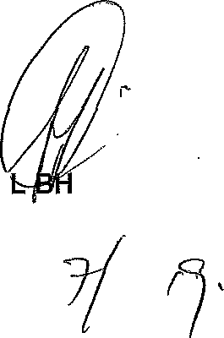
GENERA‘ MINISTER
CELE (MP) ' POLICE

