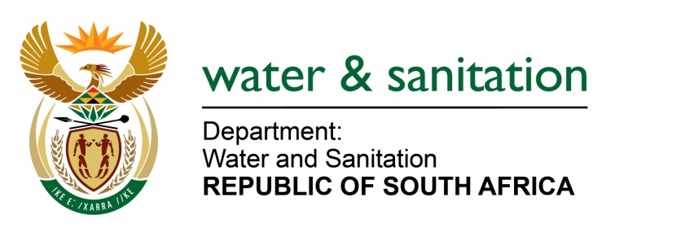

NATIONAL ASSEMBLY

FOR WRITTEN REPLY

QUESTION NO 548

DATE OF PUBLICATION IN INTERNAL QUESTION PAPER: 3 MARCH 2023
(INTERNAL QUESTION PAPER NO. 6)

548. Mr L J Basson (DA) to ask the Minister of Water and Sanitation:
(a) How does he intend to address the disaster (details furnished) facing the Republic, where dams are not compliant with safety regulations, which is precipitated by his department’s lack of capacity and (b) by what date is it envisaged that a full report on dam safety for the 323 state-owned dams will be available?
NW600E
---00O00---
MINISTER OF WATER AND SANITATION

- The Department carries out its regulatory function through its Dam Safety Office, which reported to Parliament that of the top 20 largest state dams, only 2 complied 100% with Dam Safety Regulations. The Department’s presentation to Parliament indicated that the shortcoming which was identified by the Dam Safety Office which prevented the other dams from being 100% compliant with the Dam Safety Regulations was that the required five- yearly dam safety evaluations were overdue.

Five-year Dam Safety Evaluations are required to be conducted by an Approved Professional Person (APP). These five-year evaluations are over and above the quarterly and annual inspections conducted by the Department’s operational engineering staff. There is a shortage of APPs in the Department, and this has led to the Department falling behind with its five- yearly dam safety evaluations.
The Department is in the process of finalising the appointment of a panel of Approved Professional Persons (APPs) which will assist to complete and review all required dam safety evaluation reports.
The department has prioritised 18 of the 20 largest dams to have compliant dam safety evaluation reports. with the intension to have the compliance issue resolved by the end of fourth quarter 2022/23 financial year. Unfortunately, contractual negotiations took longer than anticipated, implying that 25% of the largest 20 state dams will be achieved within this timeframe, and the remaining 75% by May 2023. With this additional professional engineering capacity, all outstanding and due dam safety evaluation reports will be completed within the next 18 months.
Even though there are inherent risks to not submitting 5 yearly dam safety evaluations reports on time, it does not necessarily equate to the dams being unsafe, since there are various systems and mechanisms in place to monitor the structural health and performance of our dams. These include routing inspections by dam operators and the monitoring of our dam’s behaviour by Dam Safety Surveillance through various instrumentations, some of which are communicating this data in real-time. All these measures are preventative in nature (serves as early warning) and are aimed at safeguarding our dam infrastructure as well as the public from potential harm.

In addition to general maintenance, the Department also implements a Dam Safety Rehabilitation programme which was established in 2006 to ensure that the lifespan of dam structures is prolonged and to improve the safety of these structures. Since its inception, rehabilitation projects at 43 dams have been completed. Currently, there are 6 dam safety rehabilitation projects underway with 19 projects in the design phase.
(b) The Department is finalising dam safety evaluation reports per dam, and not in consolidated fashion, because the due dates for these reports are staggard and not all due on the same date.
---00O00---

