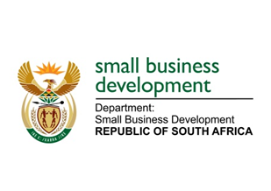
NATIONAL ASSEMBLY
QUESTION FOR WRITTEN REPLY
DUE TO PARLIAMENT: 11 MARCH 2022

“547. Mr D F Mthenjane (EFF) to ask the Minister of Small Business Development:
What has he found to be the difference between the spaza support programme run by the Small Enterprise Development Agency and the Small Enterprise Finance Agency, as compared to the spaza programme run by other private provincial organisations that have higher incentives than her department’s programme, which has a low uptake across the Republic?” NW615E

REPLY: I have been advised by the department as follows:

The Spaza Shop Support Programme as implemented by the Small Business Development Portfolio (the Department of Small Business Development [DSBD], the Small Enterprise Development Agency [Seda] and the Small Enterprise Finance Agency [sefa]) is linked to a broader process of value chain development within the retail space. This includes the concurrent linking up of beneficiaries with wholesalers, bulk buying arrangements done through Spaza Support Associations, access to SMME products at wholesalers by Spaza Shops through localisation efforts of the DSBD and its entities as well as the formalisation and strengthening of the spaza shops by working with municipalities and the banking sector.

The responsibility to implement the Spaza Shop Support Programme lies with the entities, while the DSBD co-designed the Programme with the entities it continues to monitor and review the programme to increase uptake. Anecdotal evidence gathered by the entities responsible for implementing the programme has indicated that the major difference between the DSBD programme and the programmes implemented by provincial departments centers on the following issue:
- The funding structure employed by the provinces vs that employed by the DSBD: DSBD employs a blended finance model that incorporates an equal split between grant and loan funding whereas the provincial model is entirely grant funding.

Finally, the DSBD has facilitated the participation of relevant public sector and private sector role players in the development of spaza shops by providing access to the tools developed by these role players.

MS STELLA TEMBISA NDABENI-ABRAHAMS, MP
MINISTER FOR SMALL BUSINESS DEVELOPMENT

