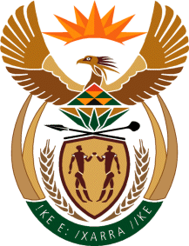

MINISTER IN THE PRESIDENCY: REPUBLIC OF SOUTH AFRICA
Private Bag X1000, Pretoria, 0001, Union Buildings, Government Avenue, PRETORIA
Tel: (012) 300 5200, Website: www.thepresidency.gov.za

NATIONAL ASSEMBLY
WRITTEN QUESTION FOR WRITTEN REPLY

QUESTION NUMBER: 546

DATE OF PUBLICATIONS: 26 February 2021

546. Mr S M Malatsi (DA) to ask the Minister in The Presidency:

What number of staff members in (a) The Presidency, (b) the Office of the Department of Planning, Monitoring and Evaluation, (c) Brand South Africa Offices, both local and abroad, and (d) Statistics South Africa lost their lives due to (i) COVID-19 and (ii) COVID-19 related complications in the period 1 March 2020 to 15 February 2021? NW602E

REPLY:
- Presidency

(i)The Presidency lost (01) female employee with a comorbidity (Disability) due to Covid 19

(ii) The Presidency lost (01) female employee due to Covid – 19 related complications in the period 01 March 2020 to 15 February 2021.
- Department of Planning, Monitoring and Evaluation

DPME lost (02) staff members excluding the late Minister in the Presidency who lost his life due to Covid – 19 related complications.
- Brand SA

No staff members, both local and abroad, lost their lives at Brand South Africa due to (i) COVID-19 and (ii) COVID-19 related complications in the period 1 March 2020 to 15 February 2021.

- Stats SA

Statistics SA unfortunately had a total of five (5) colleagues countrywide plus one (1) employee from the service provider managing the Head Office Building who succumbed to COVID-19 for the period 1 March 2020 until 28 February 2021.

The following offices were affected:
- Head Office (Pretoria) – 3 (2 Stats SA employees plus the service provider employee mentioned above)
- Bhisho District Office – 1
- Zululand District Office – 1
- De Aar District Office – 1

Stats SA does not have any employees stationed abroad.

Thank You.

