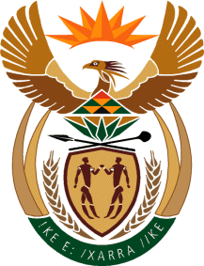

MINISTRY OF TOURISM
REPUBLIC OF SOUTH AFRICA

Private Bag X424, Pretoria, 0001, South Africa. Tel. (+27 12) 444 6780, Fax (+27 12) 444 7027
Private Bag X9154, Cape Town, 8000, South Africa. Tel. (+27 21) 469 5800, Fax: (+27 21) 465 3216

NATIONAL ASSEMBLY:

QUESTION FOR WRITTEN REPLY:
Question Number: 545
Date of Publication: 17 April 2020
NA IQP Number: 11
Date of reply: 23 April 2020

Ms H S Gumbi (DA) to ask the Minister of Tourism:
What total amount has her department injected into the Motumo Trading Post project in the Capricorn District
Municipality since its inception? NW732E

Reply:
From historical records, the project received a total of R 15 000 000 in funding, R14 000 000 in phase one between 2004 and 2007 and R1 000 000 in 2009. This funding was provided by the then Department of Environmental Affairs and Tourism. The project was handed over to the Capricorn District Municipality pre 2010.

