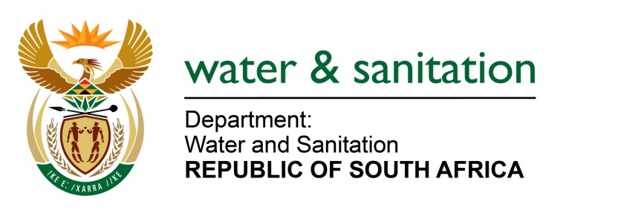

MINISTER OF WATER AND SANITATION

FOR WRITTEN REPLY

QUESTION NO 542

DATE OF PUBLICATION IN INTERNAL QUESTION PAPER: 25 FEBRUARY 2022
(INTERNAL QUESTION PAPER NO. 4)

542. Mr G R Krumbock (DA) to ask the Minister of Water and Sanitation:
What is the (a) make, (b) model, (c) year of manufacture, (d) price and (e) purchase date of each vehicle purchased for use by (i) him and (ii) the deputy minister since 29 May 2019?
---00O00---

MINISTER OF WATER AND SANITATION

- Official | (b) Make | (c) Model | (d) Year of Manufacture | (e) Purchase Price | Date Purchased/ ordered | Status
Deputy Minister Magadzi (PTA) | BMW | X3 | 2021 | R799 563.97 | 11 Oct 2021 | Delivered
Deputy Minister Magadzi (CT) | Lexus | UX 250 Hybrid SE | 2021 | R735 004.10 | 19 Nov 2021 | Ordered
Deputy Minister Mahlobo (PTA) | Audi A6 | 40TDI 140 KW S Tronic | 2021 | R 698 133.00 | 19 Nov 2021 | Ordered

---00O00---

