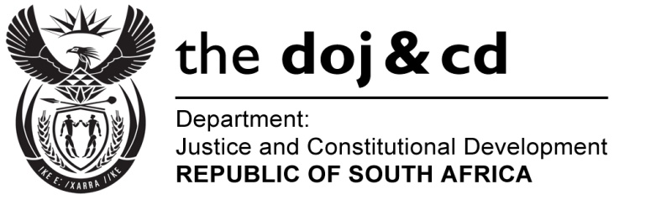

NATIONAL ASSEMBLY
QUESTION FOR WRITTEN REPLY
PARLIAMENTARY QUESTION NO.: 542
DATE OF QUESTION: 4 MARCH 2016
DATE OF REPLY: 18 MARCH 2016

542. Mr J Vos (DA) to ask the Minister of Justice and Correctional Services:
Whether, with reference to his reply to question 2968 on 7 September 2015, he has finalized his consideration of the Law Reform Commission Report on sex work; if not, why not; if so, when will he make an announcement in this regard? NW648E
REPLY:
I wish to inform the Honourable Member that I have considered the South African Law Reform Commission Project 107 Report on Sexual Offences (Adult Prostitution). It will be released on a date to be announced shortly.

