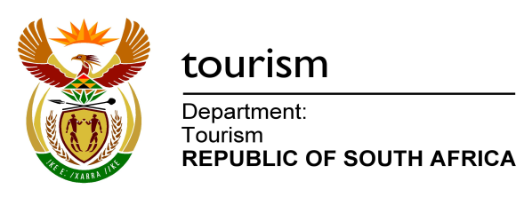

NATIONAL ASSEMBLY:

QUESTION FOR WRITTEN REPLY:
Question Number: 540
Date of Publication: 4 March 2016
NA IQP Number: 6
Date of reply:

Mr J Vos (DA) to ask the Minister of Tourism:

(1) (a) How many SA Tourism country offices are currently in operation, and (b) in which countries are these situated;

(2) what are the full details of (a) the budget in rands allocated to each of the specified offices and (b) the number of staff members employed at each of the specified offices? NW646E

Reply
- (a) 13 Country Offices are currently in operation.

(b) The South African Tourism offices are situated in the following countries:

USA
UK
Germany
France
Netherlands
Italy (to be closed in 2016/17 financial year)
India
China
Japan
Australia
Angola (rental agreement ending August 2016)
Nigeria
Brazil (General Marketing Agent)

- (a)
Country Office | 2015/16 Budgets
1. USA | R69 069 634
2. UK | R52 316 899
3. Germany | R54 297 239
4. France | R35 939 548
5. Netherlands | R27 687 781
6. Italy | R14 771 183
7. India | R32 166 316
8. China | R26 617 535
9. Japan | R12 664 850
10. Australia | R33 239 550
11. Angola | R14 251 649
12. Nigeria | R25 035 247
13. Brazil | R23 658 828

(b)

Country Office | Number of Staff (approved headcount)
1. USA | 7
2. UK | 6
3. Germany | 7
4. France | 4
5. Netherlands | 4
6. Italy | 5
7. India | 4
8. China | 5
9. Japan | 3
10. Australia | 3
11. Angola | 1 (Trade Relations Manager only)
12. Nigeria | 4
13. Brazil | General Marketing Agent

