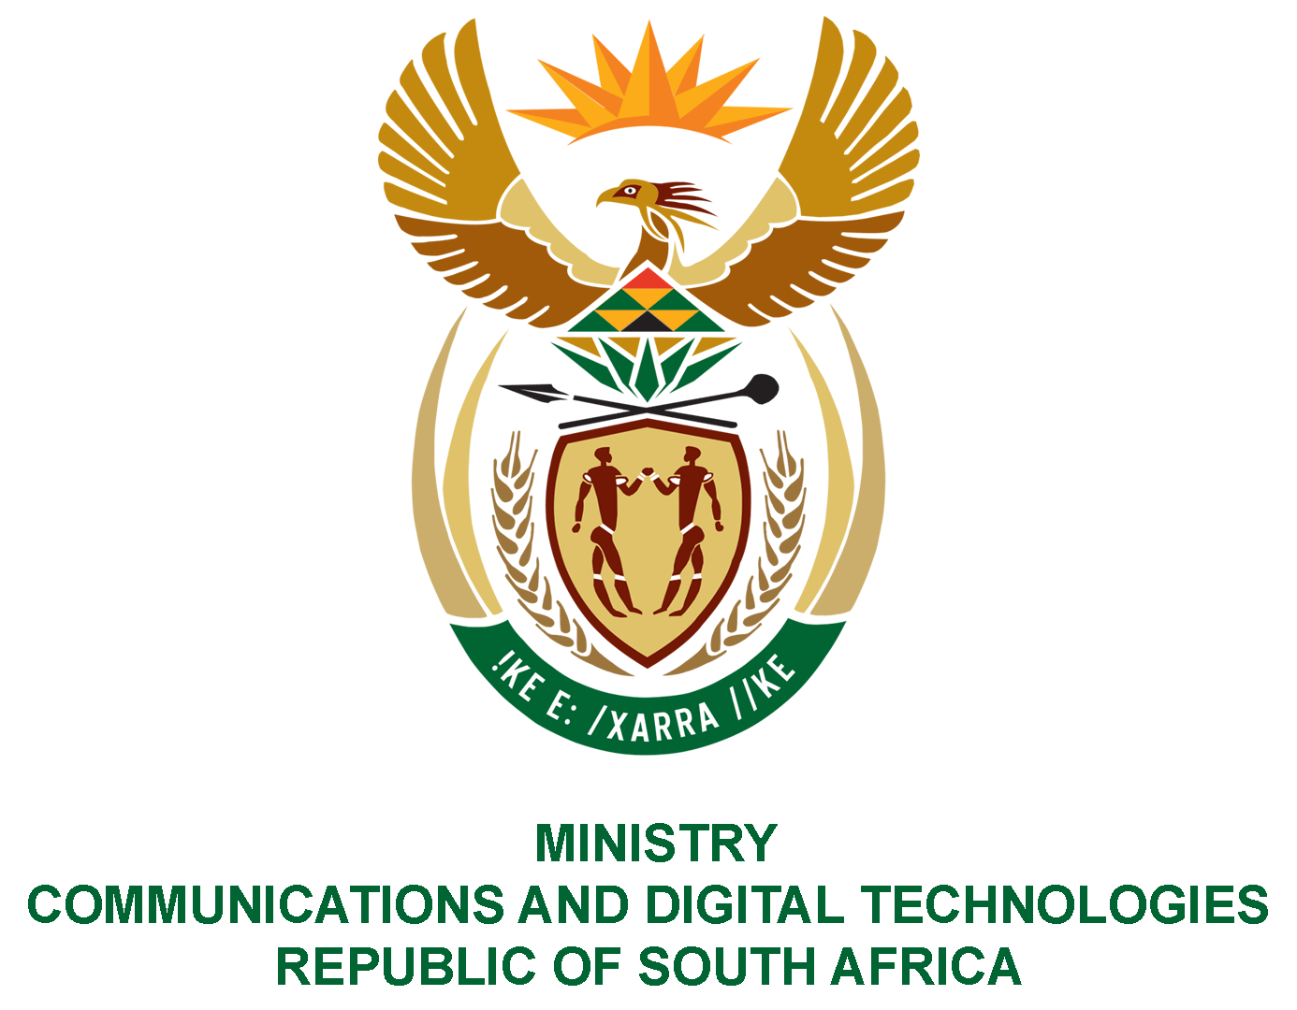

PARLIAMENT OF THE REPUBLIC OF SOUTH AFRICA
NATIONAL ASSEMBLY
WRITTEN REPLY

QUESTION NO: 539
DATE OF PUBLICATION: 26 February 2021
QUESTION PAPER NO: 4

Mr C MacKenzie (DA) to ask the Minister of Communications and Digital Technologies:
Whether the SA Post Office offers a registered email communication and/or registered SMS service to its customers; if not, why not; if so, (a) what IT system/supplier is being used to provide this service, (b) on what date was the service procured, (c) at what cost was the service procured and (d) what are the full details of the relevant tender?
NW595E
REPLY:

I have been advised by the South African Post Office (SAPO) as follows:

Yes, the South African Post Office does offer registered digital communication. There is one system in operation, namely:

- (a) Registered electronic mail system on RiPoste TrEx from Escher Group (IRL) Ltd;

- SAPO entered into the Escher contract on 29 November 2013 and a modification was done on 27 June 2016. The original design of the service was one sender to one recipient. One sales engagement with customers, it became clear that customers were looking for an automated system to cater for one sender to many recipients (bulk). The cost of the modification amounted to R17 398.00.

- The original cost was R 8 512 830.00. The maintenance cost amounted to R677 988.00 per quarter. SAPO has not paid maintenance for nine quarters due to the process of changing hosting providers. However, SAPO does not anticipate the need to pay outstanding maintenance costs.

- The registered electronic mail system was concluded on agreement number 4600000491. The tender number was RFP No 03 E Registered Mail 12/13/HM. There was no tender conducted for the revenue sharing concept, it followed an investment procedure. The SAPO/Service Provider Agreement; SAPO Limited Bidding Document; and e-Registered Mail Statement of Work Agreement is attached as Annexures B1, B2 and B3 respectively.

