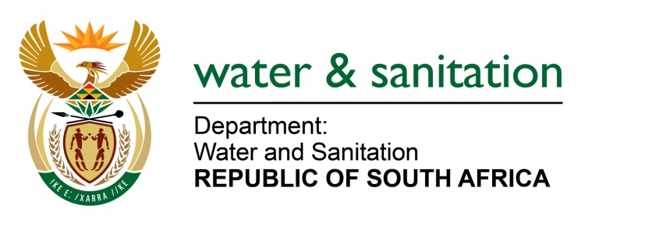

NATIONAL ASSEMBLY

FOR WRITTEN REPLY

QUESTION NO 534

DATE OF PUBLICATION IN INTERNAL QUESTION PAPER: 03 MARCH 2023
(INTERNAL QUESTION PAPER NO. 6)

534. Mrs S M Mokgotho (EFF) to ask the Minister of Water and Sanitation:
What (a) has been the total costs of the partially achieved Vaal River Intervention Programme since its inception and (b) are the projected costs for the long-awaited completion of the specified programme?
NW580E
---00O00---
MINISTER OF WATER AND SANITATION
- The total cost of the partially achieved Vaal River Intervention Programme since its inception is as follows:

Vaal River Intervention Programme expenditure
Vaal River Intervention Programme expenditure classification | 2019/20 | 2020/21 | 2021/22 | 2022/23 | Costs to date
Goods and services (OPEX) | 224,701,156 | 168,332,863 | 200,721,371 | 159,649,698 | 753,405,090
Payments for capital assets (CAPEX | - | - | 23,375,713 | 103,404,225 | 126,779,939
Total Vaal River Intervention Programme | 224,701,156 | 168,332,863 | 224,097,085 | 263,053,924 | 880,185,029

- The projected cost for the entire intervention has been estimated at a value of R7.6 billion.

