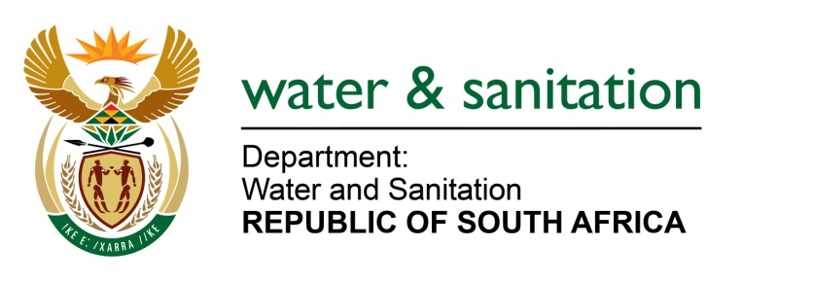

NATIONAL ASSEMBLY

FOR WRITTEN REPLY

QUESTION NO 533

DATE OF PUBLICATION IN INTERNAL QUESTION PAPER: 3 MARCH 2023
(INTERNAL QUESTION PAPER NO. 6)

533. Mrs S M Mokgotho (EFF) to ask the Minister of Water and Sanitation:
With reference to the results of the latest Green Drop assessment which noted that 43% of the water waste systems in Mpumalanga were deemed to be in a critical state and that only six out of 76 systems in the province were operating well above capacity, what measures has his department put in place to ensure that all municipalities in Mpumalanga score 90% to comply with water waste standards?
NW579E
---00O00---

MINISTER OF WATER AND SANITATION

In response to the release of the Green Drop report for 2022, the department issued non-compliance letters to all Water Services Institutions (WSIs) with wastewater systems at critical state (achieved GD score of less than 31%). The non-compliance letters required the WSIs to develop the corrective action plan that will address the issues as identified on the 2022 report.

The department also engaged Local Municipalities within the Mpumalanga province on numerous occasions on the Green Drop (GD) 2022 report findings. This was meant to:
- Encourage those municipalities with wastewater systems that were found to be in a critical state to develop the corrective action plans
- Advise on best practices for wastewater management to improve performance
The department also provided training that was attended by all WSAs in MP to guide, improve and enhance the performance of the WSAs regarding management of the water and wastewater systems. In addition, a working session was held with all the municipal councillors to discuss the outcomes of the GD/BD reports and the poor performance of water & wastewater systems within the province. A commitment to support the GD/BD programme to ensure compliance was made on the date of the session.

The department, in collaboration with provincial Cooperative Governance and Traditional Affairs (COGTA) departments, District Municipalities and South African Local Government Association (SALGA), continues to strengthen engagements with municipalities to ensure that the WSAs manage water and wastewater systems in a sustainable way to protect the water resources and improve service delivery to the communities.

A Water Service Task Team has been established with all WSAs in Mpumalanga Province to address several critical factors caused by lack of capability to manage, operate, and maintain infrastructure. Other critical matters to be addressed by the Task Team include the following:
  - Financial planning, budgeting, and expenditure
- Procurement processes
- Lack of preventative maintenance
- Poor capacity management
- Poor effluent quality

Furthermore, the department continues to monitor the performance of all water/wastewater systems within the province annually to ensure compliance with the Water Services Act and National Water Act. When there are failures to comply with the requirements of legislation, the department is compelled to initiate enforcement action against the WSAs.

---00O00---

