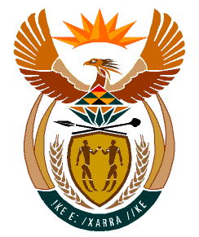

MINISTRY:
HUMAN SETTLEMENTS, WATER AND SANITATION
REPUBLIC OF SOUTH AFRICA

NATIONAL ASSEMBLY

QUESTION FOR WRITTEN REPLY

QUESTION NO.: 533

DATE OF PUBLICATION: 17 APRIL 2020

Mrs C Phillips (DA) to ask the Minister of Human Settlements, Water and Sanitation:
(1) Why was no provision made to supplement the existing water supply to the town Derby and/or Redirile in the North West when the size of the town has increased threefold (details furnished);

(2) are there any plans to connect the towns up to a supply line from Randwater; if not, why not; if so, what are the relevant details? NW720E

REPLY:
(1) The Kgetleng Rivier Local Municipality (KRLM) recently increased the existing water supply of 1.1 Ml/d of water by drilling nine (9) boreholes in the Redirile Township. The boreholes are not yet connected to the Eskom network due to delays by Eskom. The new boreholes tested positive and will provide an additional 1.2 Ml/d as soon as they are functional. The municipality is investigating whether an additional three (3) boreholes could be drilled in the 2020/2021 financial year in order to meet the increasing water demand and mitigate water shortages in the area.

(2) The Local Municipality has appointed the Development Bank of South Africa (DBSA) to investigate possible solutions to provide sustainable water supply to the entire jurisdiction of the Kgetleng Rivier Local Municipality area. Plans are underway to consider the feasibility of integrating the systems of the neighbouring towns and to connect it to the Rand Water supply pipeline.

The current water supply by Rand Water Board is approximately 1.8 Ml/d. The new informal settlements areas in the KRLM jurisdiction are served by boreholes. The Local Municipality is currently developing a Water Master Plan that will include a practicable solution to provide bulk water to Derby and Redirile.

