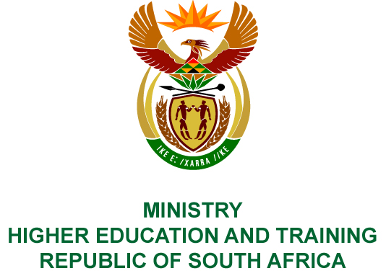
Private Bag X893, Pretoria, 0001, Tel: 012 312 5555, Fax: 012 323 5618
Private Bag X9192, Cape Town, 8000, Tel: 021 469 5150, Fax: 021 465 7956
MEMORANDUM FROM THE PARLIAMENTARY OFFICE
NATIONAL ASSEMBLY
FOR WRITTEN REPLY
QUESTION 531
DATE OF PUBLICATION OF INTERNAL QUESTION PAPER: 08/03/2019
INTERNAL QUESTION PAPER NO 07 OF 2019
Ms N Nolutshungu (EFF) to ask the Minister of Higher Education and Training:
What number of teachers graduated from each of the country’s institutions of higher learning in 2018?
NW564E
REPLY:
The universities start identifying their graduates for the 2018 academic year once all the supplementary and postgraduate examinations have been completed. Thereafter they will commence with the auditing of this data. The 2018 audited Higher Education Information Management System (HEMIS) data from all 26 public universities is due at the end of
July 2019. The audit reports will be checked and data verified by the end of October 2019. Verified graduate data for the 2018 academic year will only be available in November 2019.

