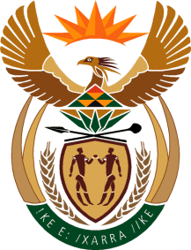

MINISTRY OF TOURISM
REPUBLIC OF SOUTH AFRICA

Private Bag X424, Pretoria, 0001, South Africa. Tel. (+27 12) 444 6780, Fax (+27 12) 444 7027
Private Bag X9154, Cape Town, 8000, South Africa. Tel. (+27 21) 469 5800, Fax: (+27 21) 465 3216

NATIONAL ASSEMBLY:

QUESTION FOR WRITTEN REPLY:
Question Number: 528
Date of Publication: 1 March 2019
NA IQP Number: 5
Date of reply: 6 March 2019

Mr T Rawula (EFF) to ask the Minister of Tourism:
(a) What number of (i) buildings, (ii) properties and (iii) facilities does his department currently (aa) own and (bb) rent, (b) what is the value and purpose of each (i) owned and (ii) rented property and (c)(i) for how long has each property been rented, (ii) from whom is each property rented and (iii) what is the monthly rental fee for each property? NW598E

Reply
- (i) –(iii) (aa) The department does not own any buildings, properties or facilities.
(bb) The Department of Tourism has a rental agreement with the Department of Public Works.

- What is the value and purpose of each
- Not applicable as the department does not own a building.
- As the department rents the property from the Department of Public Works the value of the property is not known.

(c ) (i) The department has rented the building since June 2011.

- The building has been rented from the Department of Public Works.

- The Department of Tourism pays the Department of Public Works a monthly rental fee of
R 3 414 078.96

