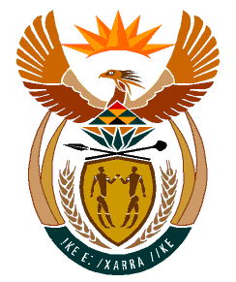

MINISTRY:
HUMAN SETTLEMENTS, WATER AND SANITATION
REPUBLIC OF SOUTH AFRICA

NATIONAL ASSEMBLY

QUESTION FOR WRITTEN REPLY

QUESTION NO.: 522

DATE OF PUBLICATION: 23 August 2019

Mr I S Seitlholo (DA) to ask the Minister of Human Settlements, Water and Sanitation:
(1) With reference to the reply of the former Minister of Water and Sanitation to question 3369 on 7 October 2015, and question 3370 on 7 October 2015, what is the (a) current status of the construction of the new (i) water purification plant in Bloemhof in the North West and (ii) pipeline from Bloemhof to Schweizer-Reneke and (b) expected date of completion of each project;
(2) what (a) is the current total cost of the construction of the (i) plant and (ii) pipeline and (b) costs were incurred in respect of each contractor employed to date? NW1516E

REPLY:
(1)(a) (i) The new water purification plant in Bloemhof is at 89% completion.
(ii) The entire pipeline from Bloemhof to Schweizer-Reneke is 60km long. However, my Department is currently working on the construction of the first 11km. The progress is at 50% towards completion.

(b) Both the water purification plant and the 11km pipeline will be completed in December 2019 and the plan is to complete the entire project by December 2020.

(2)(a) (i) The current total cost of the construction of the plant is R120 million.

(ii) The current total cost of the construction of the pipeline is R278, 490,800.

(b) The costs incurred in respect of the contractor for the Water Treatment Plant is R75 580 million, and for the pipeline it is R21 980 million. This includes the fees of the engineers.

