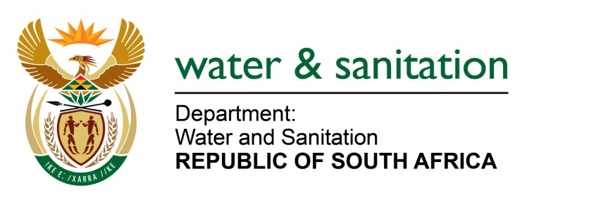

NATIONAL ASSEMBLY

FOR WRITTEN REPLY

QUESTION NO 520

DATE OF PUBLICATION IN INTERNAL QUESTION PAPER: 3 MARCH 2023
(INTERNAL QUESTION PAPER NO. 6)

520. Ms S A Buthelezi (IFP) to ask the Minister of Water and Sanitation:
With reference to the opening of two more dams at the Vaal Dam which could result in the higher possibility of a flood, what (a) measures does his department have in place in terms of developing a flood preparedness plan and implementation of flood monitoring and forecasting systems to counter the impact on surrounding communities that may be affected and (b) alarm measures have been implemented and exposed to the communities around the dam?
NW562E
---00O00---

MINISTER OF WATER AND SANITATION

Ahead of the opening of two more gates at Vaal Dam, warnings were issued to the public through various media platforms and an official media statement issued by the department.

- Development of a flood preparedness plan takes place every year before the rainy season. The implementation of flood monitoring and forecasting systems is a continuous process that the department uses to monitor the state of water flow in the rivers. This ultimately informs decision making regarding issuance of early warnings and opening of flood gates whenever necessary.

- The alarm measures implemented and exposed to the communities around the dam include issuing of official media statements, dam operators post warnings in social media groups of exposed communities about impending flood control releases and the inevitable increase of water levels downstream.

This ensures that these warnings reach communities swiftly once decisions to release water are confirmed to allow sufficient lead time to react to the interventions.

