FOR WRITTEN REPLY QUESTION 518

NATIONAL ASSEMBLY

36/1/4/1(201900155)

DATE OF PUBLICATION IN INTERNAL QUESTION PAPER: 23 AUGUST 2019 (INTERNAL QUESTION PAPER NO 10-2010)

518. Mr A G WhiUield (DA) to ask the Minister of Police:

(a) What 1s the total number of detectives in each provlnce and (b) in each case, what 1s the total number who has undergone (i). formal detective training and (ii) advanced and/or speclallsed detective training?
NW1511E
REPLY:

(a) The total number of detectives, in each province, is reflected in the table below:

Province | Total number of Detectives (Police Act  Personnel, at 31 August 2019)
Western Cape | 3 294
Eastern Cape | 3 025
Northern Cape | 1 072
Free State | 1 674
KwaZulu-Natal | 4 060
North West | 1 336
Mpumatanga | 1 629
Limpopo | 1 567
Gauteng | 7 056
TOTAL: | 24 713

(b)(i)(ii) The total number of detectives, in each province, who have undergone formal detective training and advanced and/or specialised detectiVe training, is reflected in the table below:

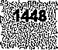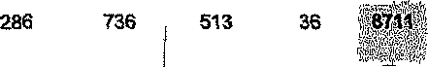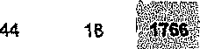

 | TnveetTgatfve Practice |  |  |  |  |  | 1350
 |  | 4968 | t7g | 2718 | 1092 | 12s7
 | Learning Programme |  |  |  | 370 |  | 138 | 149 | 305 | Z?'3 | 86
 |  | 113 | gg |  | 1M | aa | 8s | 46 | 09
 | Serious and Violent  Crimes | 128 | 72 | Z24 | 107 |  |  | 51 | 78
 |  |  |  |  |  |  | 54 | zs | 36
stock Nett
Investigators course
 | Vehicle Crime  4nvesfigators Cgurse | 2O2 | 432 | 318 | j$g |  | 104
 | Commercial Come | t03 | 73 | 183
 | ramny Violence, sexual  Proi•ction | 371 | IN | 616 | 4U | 240 | zso
 |  | 874 | 445 | 2607 | 1012 |  | 530
 | SAPS 6 aztd Docket | 191 | 677 | 143 | ZM |  | 63 |  | 22
 |  | 1604 | 4' | H58 | 4016 | 1M2 | 10S

Reply to question 518 recommended/Ceded

COI!II
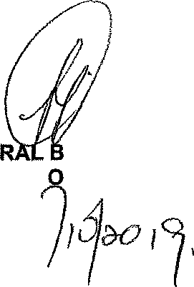
LE (SOEG)
Reply to question 518 approved/oet

GENE H CELE (MP) MINISTER F POLICE

Date: @
GENERAL
TH AFRICAN POLICE SERVICE

