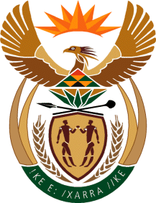

MINISTRY: COMMUNICATIONS
REPUBLIC OF SOUTH AFRICA
Private Bag X 745, Pretoria, 0001, Tel: +27 12 473 0164 Fax: +27 12 473 0585
Tshedimosetso House,1035 Francis Baard Street, Tshedimosetso House, Pretoria, 1000

NATIONAL ASSEMBLY
QUESTION FOR WRITTEN REPLY
QUESTION NUMBER: 517
DATE OF PUBLICATION: FEBRUARY 2016

Mr T Z Hadebe (DA) to ask the Minister of Communications:
Whether the progress report of the allegations made against the Media Development and Diversity Agency about processes and procedures around (a) supply chain management, (b) organisational structures and (c) human resources processes in its 2012-13 Annual Report will be included in its 2014-15 Annual Report; if not, (i) why not and (ii)(aa) how and (bb) when will such a report be made available; if so, (aaa) why was the progress report not published in the 2013-14 Annual Report and (bbb) what are the further relevant details? NW571E

REPLY: MINISTER OF COMMUNICATIONS

The 2014/15 annual report has already been published in September 2015, and all audit findings were addressed accordingly as remedial actions which will be included in the 2015/16 annual report currently being drafted.

MR NN MUNZHELELE
DIRECTOR GENERAL [ACTING]
DEPARTMENT OF COMMUNICATIONS
DATE:

MS AF MUTHAMBI (MP)
MINISTER OF COMMUNICATIONS
DATE

