NATIONAL ASSEMBLY QUESTION FOR WRITTEN REPLY QUESTION NUMBER: 512
DATE OF PUBLICATION IN INTERNAL QUESTION PAPER: 1 March 201B INTERNAL QUESTION PAPER NUMBER: 5 - 2019

512. Ms N P Sonti (EFF) to ask the Minlstar of Social Development:

- V\/hat number of (i) buildings, (ii) properties and (iii) facilities does her department currently (aa) own and (bb) rent, (b) what is the value and purpose of each (i) owned and (ii) rented property and (c)(i) for how long has each property been rented, (ii) from whom is each property rented and (iii) what is the monthly rental fee for each property†

REPLY:
- (i) (ii) (iii)

- (i)

2 Buildings.
Leases 2 properties. (aa) None.
(bb) 2. None.

NW578E

(ii) To accommodate National Department of Social Development and the
Social Security Branch at Harlequins Office Park.
The National Department of Social Development has lsased office accommodation since 2001.
Social Security Branch at Harlequins Office Park has leased office
accommodation since 2000.
The National Department of Social Development has leased office accommodation f‹om the Human Science Reach Council (HSRC).
Social Security Branch at Harlequin6 Office Park has leased office accommodation from Delta Properties.
The National Department of Social Development has leased office
accommoda"t›on from the Human Science Reach Council (HSRC) for
R2 284 518.83.
Social Security Branch at Harlequins Office Park has leased office accommodation from Delta Properties for R574 589.37

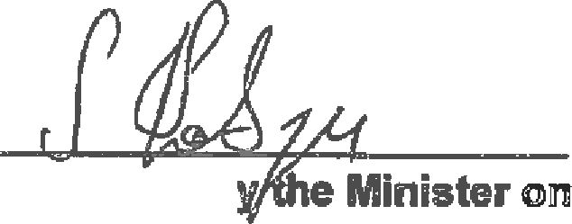

Approved b

