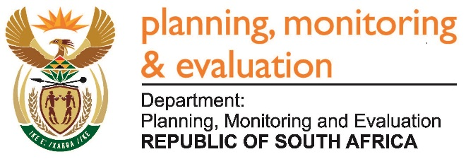 |  | 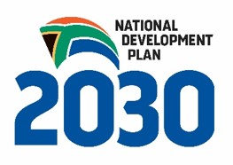
Private Bag X944, PRETORIA, 0001. Union Buildings East Wing, Government Avenue, PRETORIA
Tel: 012 312 0307. www.dpme.gov.za
512. Mr H C C Krüger (DA) to ask the Minister in the Presidency:
Whether any Red Tape was removed on regulatory measures that influence small businesses since the introduction of the Social Economical Impact Assessment Unit; if not, why not; if so, (a) what are the details of the regulatory measures, (b) in which sector did the regulatory measures apply, (c) what burden was relieved and (d) what was the outcome of the intervention? NW569E
Reply:
SEIAS is focusing on ex ante analysis on impact of proposed policies, legislations and regulations before they are approved or passed as Acts of Parliament. Through SEIAS, departments are able to proactively address areas that can create regulatory burden, potential risks that can result in unintended consequences or even high costs for implementation or litigation costs.
SEIAS Unit is not responsible for the Red Tape Reduction which is being addressed by Department of Small Business Development.
Impact on legislation is monitored through different instruments such as performance monitoring of outcomes and Annual Performance Plans, Service Delivery Improvement Plans (SDIPs), Operation Phakisa, Front Line Service Delivery and etc.

